***Garage92***

***A web-based application for Vehicle service management system***

Garage92 “A web-based application for Vehicle service management system”

A PROJECT REPORT HAS BEEN SUBMITTED TO GOA UNIVERSITY

IN PARTIAL FULLFILLMENT OF THE REQUIREMENT

FOR THE DEGREE OF BCA

BY

|  |  |  |
| --- | --- | --- |
| **Roll No** | **Name** | **Signature** |
| B19601 | Mr Murtaza Azizi |  |
| B19622 | Mr. Zaid Sayed |  |
| B19627 | Mr. Savio Silveira |  |
| B19630 | Mr. Om Gorantiwar |  |
| B19631 | Mr. Joshua John |  |

___________ __________________ ___________________

Ms. Arti Naik Ms. Nitisha Govekar Prof. Savio P. Falleiro

(Internal Guide) (Project Co-ordinator) (Principal)

Fr. Agnel College of Arts and Commerce, Pilar-Goa

2021-2022

Garage92 “A web-based application for Vehicle service management system”



Fr. Agnel College of Arts and Commerce, Pilar-Goa

Affiliated to Goa University

**CERTIFICATE**

This to certify that project on

**Garage92**

has been successfully completed by

Mr .Murtaza Azizi

Mr. Zaid Sayed

Mr. Savio Silveira

Mr. Om Gorantiwar

Mr. Joshua John

Studying in T.Y.B.C.A. during the academic year 2021-22

The project has been carried out under the supervision of the Internal Guide

_______________ _______________ _______________ _______________

Ms. Arti naik Prof. Savio P. Falleiro Ms. Nitisha Govekar

(Internal Guide) (External Examiner) (Principal) (Project Co-ordinator)

Place: Pilar-Goa

Date: ___________

**Acknowledgment**

It is our great pleasure to present our project “Garage92” a web-based application so people can book appointment for vehicle servicing

As a group, we have put all put in equal efforts to develop this project. However, it would not have been possible without the kind support and help of the superiors and faculty of Fr. Agnel College of Arts and Commerce, Pilar-Goa.

We are greatly thankful to our mentor Asst. Prof. Arti Naik, as well as our BCA coordinator for their guidance, constant supervision and support while providing us with the necessary details to help us develop the project.

Our thanks and appreciation also go to our colleagues and others who have helped us out with their abilities for their kind co-corporation and encouragement in our endeavor.

-The Project Group

**ABSTRACT**

 We live in a digital era where everyone expects quick services. Our project aims to transform the current functionality of the Garage from manual vehicle service booking to online vehicle service booking. For our project we have developed a vehicle service management System where users can get appointments for vehicle service Through our web-based application Garage 92. It also ensures that users can see status of service (complete, pending selected, rejected) and can check timings of store, contact, location, types of service we provide, about the store. once servicing of vehicle is done our Web based will send a reminder email to respective user and user can send enquiry to admin for any query not only that from our web-based application user can pay through online mode with the help of razorpay.

**Table of Contents**

Chapter 1: INTRODUCTION

* 1. Introduction……………………………………………………………………..…….02
  2. Existing system and its limitation……… ….……………………………….…..….…02

1.3Features of Proposed System……...……………………………………...………...….02

1.4 Our application…………...…...………………………………………………….…...03

1.5 Scope……………………….………………………………………………................03

1.5 Objective………………….………………………………………………...................03

Chapter 2: FEASIBILITY STUDY

2.1 Introduction……………………………………………………...………....................05

2.1.1 Operational feasibility…………………………………………………....................05

2.1.2 Usability Feasibility……………...………………………………............................06

2.1.4 Schedule Feasibility………...…………………………………………….………...06

2.1.3 Technical Feasibility………………………………………………………………..06

2.1.5 Economic Feasibility………...…………………………………………….……......06

2.2 Modules……………………………………………………………….........................07

2.2.1 User Modules…………………………………………………………….………….07

2.2.2 Admin Modules…………………………………………………...….……………..07

Chapter 3:SOFTWARE REQUIREMENTS AND SPECIFICATION

3.1 Introduction…………………………………………………………………………...10

3.2 Project Requirement……………………………………………..................................10

3.2.1 Software Requirement………………………………………………………………10

3.2.2 Hardware Requirement…...…………………………………………………………11

3.2.3 User Requirements …………………………………………………………............11

3.2.4 Performance Requirements ……………………………………………..………….11

3.2.4.1 Speed …………………………………………………………...………………...11

3.2.4.2 Space ……………..……………………………………..…...................................11

3.2.4.3 Usability …………….…………………………………..…..................................11

Chapter 4: DESIGN SPECIFICATION & ANALYSIS

4.1 ER diagram ……………………………………………….…………………………..13

4.2 Activity diagram …………………...…………………………………..………...…...14

4.2.1User……………………………………...……………………………………..……14

4.2.1.1 Get appointment module ……………………………..…………...………...……14

4.2.1.2 Enquiry request module ………………………….........….....................................15

4.2.1.3 Forgot Password module …………………………………..…………..…………16

4.2.1.4 User my profile module …………………………………...………….….……….17

4.2.1.5 User login/registration module……………………………………….…….…..…18

4.2.1.6 User Change password …………………………………………………….…..…19

4.2.2 Admin…………………………………………………………………...…….…….20

4.2.2.1 Admin service request module ………………………………….……………..…20

4.2.2.2 Admin vehicle servicing module …………………………..…………………..…21

4.2.2.3 Admin enquiry requests ………………………………………………………..…22

4.2.2.4 Admin mechanics module ……………………………………………………..…23

4.2.2.5 Admin vehicle category module ………………………………..……….……..…24

4.2.2.6 Admin generate invoice module ………………………………..……….……..…25

4.2.2.7 Admin profile module…………………………………………...………………..26

4.2.2.8 Admin change password……………………………………….………….………27

4.3 Class diagram……………………………………………………………...………….28

4.4 Use case diagram……………………………………………………….……………..29

Chapter 5: IMPLEMENTATION AND TOOL USED

5.1 Introduction……………………………………………………………………..…….31

5.1.1 SDLC……………………………………..…………………………........................31

5.1.2 Incremental Model …………………………………………….……………………31

5.2 Backend Software Tools………………………………………….…………………...32

5.2.1 PHP………………………………………….............................................................32

5.2.1 MySQL……………………………………………………………..……………….32

5.3 Editing tool ………………………………………………………………….………..32

5.3.1 Visual Studio Code………………………………………………………..………...32

5.4 Technologies used………………………………………………………..…………...33

5.4.1 Apache HTTP server …………………………………………….............................33

5.4.2 MySQL…………………………………….……………………..............................33

5.4.3 Gantt Project ………………………..………………………………………………33

5.5 Front End Tools……………………….……………………………............................34

5.5.1 HTML……………………………………………………………………...………..34

5.5.2 CSS………………………………………………………………………………….34

5.5.3 JavaScript………………………………………………………………..………….34

5.5.4 Bootstrap………..…………………………………………………………………...34

5.6 Middleware and auxiliary tools used………………………………………….………35

5.6.1 Razorpay API……………………………………………………………….………35

5.6.2 Gmail API………………………………...................................................................35

Chapter 6: SOFTWARE TESTING AND DEPLOYMENT

6.1 Introduction………………………………………………………………….………..37

6.2 Manual Testing………………………………………………………………..………37

6.2.1 Unit testing ………………………………………………………………………....37

6.2.2 Integration testing…………………………………………………………………...38

6.3 Test cases for registration page ………………………………………………………39

6.4 Test cases for login page ……………………………………………………………..41

6.5 Test Cases for Forgot Password………………………………………………..……..43

6.6 Test cases for reset password page ………………………………….………...…..….44

6.7 Test cases for User navigation bar………………………………………….................46

6.8 Test Cases for Update Profile…………………………………………………..……..48

6.9 Test Cases for home page …………………………………………………………….50

6.10Test Cases for About us Page………………………………………………...……....51

6.11 Test Cases for location Page ………………………………………...……………....52

6.12 Test Cases for enquiry page …………………………………………………...……53

6.13 Test Cases for enquiry history page ………………………………………..……….54

6.14 Test Cases for service request form …………………………………………...……55

6.15 Test Cases for service history page ………………………………………………....58

6.16 Test cases for logout …………………………………………………..…………….61

6.17 Test Cases for admin Login page……………………………………….……….…..62

6.18 Test cases for Admin dashboard ……………………………………………….……64

6.19 Test cases for Add Mechanics..………………………………………..…………….65

6.20 Test cases for Manage Mechanics..…………………………………………..……...67

6.21 Test cases for Update mechanics …………………………………………………....69

6.22 Test cases for add category(vehicle)………………....……………...………………71

6.23 Test cases for manage category(vehicle)…………………………….………..……..72

6.24 Test cases for edit category…………………………………..……………………...73

6.25 Test cases for new service request …………………………………….…………….74

6.26 Test cases for rejected services ……………………………………….……………..76

6.27 Test cases for servicing (pending)………………………………………...…………77

6.28 Test cases for servicing (completed)………………………………………...………80

6.29 Test cases for invoices…………………………………………………………...…..82

6.30 Test cases for generate invoice page………………………………………………...84

6.31 Test cases for enquiry page (not responded)…………………………………...……86

6.32 Test cases for enquiry page (responded) ……………………………………………88

6.33 Test cases for admin profile page……………………………………………………89

6.34 Test cases for change password page(admin) ………………………………………91

6.35 Test cases for admin sidebar………………………………..……………….…….…93

6.36 Test cases for logout……………………………………………………….………...96

Chapter 7: USER HELP MANUAL

7.1 User ……………………………………………………………………………..…...98

7.1.2 User Page………………………………………………………..……………….....98

7.1.3 Change password……………………………………………………………………99

7.1.4 Home Page…………………………………………………………………..…..…100

7.1.5 About us……………………………………………………..……………..………101

7.1.6 Contact ID and footer………………………………….………..……….……...…102

7.1.7 Location…………………………………………………………..…………..……103

7.1.8 Booking page………………………………………………….…...………………104

7.1.9 Booking Form…………………………………………………….………..………105

7.1.10 Service History…………………………………………………….………..……106

7.1.11 Enquiry page…………………………………………………………...…………107

7.1.12 Enquiry History…………………………………………………………..………108

7.1.13 My Profile………………………………………………………………..……….109

7.2 Admin…………………………………………………………………...…………...110

7.2.1 Admin log-in…………………………………………………………………...….110

7.2.2 Change Password…………………………………………………………….…….111

7.2.3 Admin Dashboard…………………………………………………………...……..112

7.2.4 Add Mechanics…………………………………………………………....……….113

7.2.5 Manage mechanics……………………………………………………….………..114

7.2.6 Add Vehicle category…………………………………………………...…………115

7.2.7 Manage category………………………………………………………...………...116

7.2.8 Service request new………………………………………………………...……...117

7.2.9 Service Rejected……………………………………………………...……………118

7.2.10 Service Pending…………………………………………………………………..119

7.2.11 Service Completed………………………………………………….…………….120

7.2.12 Generating invoice……………………………………………..…...…………….121

7.2.13 Customer Enquiry………………………………………………………...………122

7.2.14 Responded Enquiry……………………………………….……………...………123

Chapter 8: CONCLUSION AND FUTURE ENHANCEMENT

8.1 Conclusion………………………………………………………….………………..125

8.2 Future enhancement………………………………….………………………………126

8.3 Reference…………………………………………………………….………………127

8.4 Bibliography…………………………………………………...…………………….128

Annexure III………..………………………………………………………..….….........129

Annexure VII………..………………………………………………………..…….........134

Annexure V………..………………………………………………………..……...........135

**CHAPTER 1**

**INTRODUCTION**

**GARAGE92**

**1.1 Introduction to system**

Garage92 is a web-based applications for vehicle service management system. the core concept of project is to make booking of vehicle service.

**1.2 Existing system & its limitation**

In traditional service booking for to book a vehicle service costumer has to visit garage every time to his/her appointment of vehicle service sometimes appointment reached to its limits and have to close the appointment service or he/she has to come tomorrow to book their vehicle service again but costumer is didn't aware of that and this leads to cancellation of appointment or delays when costumer comes late to book an appointment for vehicle service

1) Costumer has to visit garage every time to book their vehicle service

2) To enquire time of the store or any enquiry related to servicing of vehicle still has to visit garage

3) If appointment reached to its limit them costumer have to come again tomorrow for next day booking s

4) Costumer has to carry cash to pay for servicing means there is no flexibility in the payment mod

**1.3 Featured of proposed system**

Garage 92 is a web-based applications for vehicle service booking where user can get appointment for vehicle service Through our web-based application Garage 92 has lots of potential delimitating the traditional system of vehicle service booking this project ensures to book vehicle service remotely at any time. from our application apart from that user can see status of service (complete, pending selected, rejected) and can check timings of store, contact, location types of service we provide ,about the store. once servicing of vehicle is done our Web based will send a reminder email to respective user and user can send enquiry to admin for any query not only that from our web-based application user can pay through online mode with the help of razorpay and for admin can add, manage mechanic this will help to do operation of vehicle servicing effectively

**1.4 Our Application**

" Garage92 “: A Web Application for Vehicle Service Management System. The core concept of the project is to book an appointment for vehicle service.

**1.5 Scope**

In the Garage industry , the project has a lot of potentials . By integrating our application with current Garages , it will ensure to book vehicle service remotely at any time.

**1.6 Objective**

Our Garage92 website will allow customers to book an appointment for vehicle service so that costumer don’t have to visit garage every time to just get an appointment for vehicle service. Our website will show a verity of services we provide and location. By booking an appointment through website will allow customers can pay in online mode and save their valuable time and they won’t been dealing with trouble to get to the garage.

**CHAPTER 2**

**FEASIBILITY STUDY**

**2.1 Introduction**

After the problem statement is clearly understood the next step is checking the feasibility of the system. It is necessary to determine whether the outcome of the preliminary investigation is feasible. It is both necessary and prudent to evaluate the feasibility of a project at the earliest possible time. A feasibility study is a test of a system proposal regarding its workability, impact on the organization, ability to meet user needs, and effective use of resources. Thus, when a new application is proposed, it normally goes through a feasibility study and is approved for development. For any project to be successful, there is a need for an effective feasibility study. The problem is worth solving. This software has been tested for various feasibility criterions from various points of views.

**1.** Operational feasibility

**2.** Usability Feasibility

**3.** Economic feasibility

**4.** Schedule Feasibility

**5.** Technical Feasibility

**2.1.1 Operational** **Feasibility:**Operational feasibility is the measure of how well a proposed system solves the problems, and takes advantage of the opportunities identified during scope definition and how it satisfies the requirements identified in the requirements analysis phase of system development**.**  
A vehicle service management system. In Operational feasibility the customer doesn't need to go to the vehicle service centre every time for booking through our application. The customers can book it anywhere even in a remote location and our client’s customers can fulfil their requirements such as getting the types of service we provide, whichever time can select for booking means flexibility, can ask any query through enquiry module.

**2.1.2 Usability Feasibility:**Usability is design factor that affect the user experience of operating the application device and navigating the application for its intended purpose in our user interface design we will provide appointment request form to book service of vehicle as per his/her convenience, for enquiry related query our system will provide enquiry request form so user can ask any query to admin and our interface will be easy to use and navigate.

**2.1.3 Schedule Feasibility:**Schedule feasibility is the degree to which a deadline for a strategy, plan, project or process is realistic and achievable.  
In this project, the project schedule is interpreted in the form of a Gantt chart for identifying schedule feasibility. The following chart depicts the time period of each task in the project units have taken, as compared to real time. This will ensure that the project is being completed successfully.

**2.1.4 Technical Feasibility:**A technical feasibility study assesses the details of how you intend to deliver a product or service to customers. It's the logistical or tactical plan of how your business will produce, store, deliver, and track its products or services.  
These are the main technologies used in our project  
HTML 5, CSS, MySQL, JavaScript, PHP, Bootstrap etc..  
They are readily available and the technical skills are feasible

**2.1.5 Economic Feasibility:**The economic feasibility step of business development is that period during which a break-even financial model of the business venture is developed based on all costs associated with taking the product from idea to market and achieving sales sufficient to satisfy debt or investment requirements.  
(Cost benefit Analysis) Being a web application which allows users to book an appointment at their convenience, this website will have a hosting charge. No cost will be charged from the customers who have booked an appointment to analyse the condition.

**2.2 Modules**

**2.2.1 User**

**1.** **Enquiry**: In this section the user can fill the enquiry form and check if his query is responded or not (which is done by admin).

**2**. **Service** **Request**: In this section users can fill the service form, check his/her service status and what amount is taken for service and also print his/her amount slip (which is done by admin).

**3**. **Enquiry history**: In this section user can see all the enquiry that he/she send enquiry to admin in past

**4.Service service:** In this section the user can see all services that he/she applied for service in the past with help of customer phone number, email id or contact number.

**5. Forgot password:** In this section if user forget his/her password once he/she clicks on forgot password then system will send an email with change password link

User can also update his/ her profile, change password and recover password.

**2.2.2 Admin**

Secure admin login system

**Dashboard**: In this section admin can see all details in brief like total registered user, Total Enquiry, Total Mechanics and Total Services.

**Mechanics:** In this section admin can manage mechanics (add, delete, and update).

**Vehicle Category**: In this section admin can manage vehicle category (add, delete and update).

**Service Request**: In this section admin can add service prices (service charge, parts charge additional (if any)). Admin can view services on the basis of status (pending services, rejected services and complete services). Admin also can approve pending policy

**Customer Query:** In this section admin can respond to the customer query and also view the customer responded query and non-responded query.

**Generate invoice:** in this section we are using razorpay api and admin can generate invoice and send that invoice through the respective user email and user can do payment with help of razorpay.

**CHAPTER 3**

**SOFTWARE REQUIRMENT SPECIFICATIONS**

**3.1 Introduction**

A software requirement specification (SRS) is a comprehensive description of the intended purpose and environment for software under development. The SRS fully describes what our software will do and how it will be expected to perform. The description of the various services provided by " Garage92 '' for the customer and the constraints under which it operates and is developed.

**3.2 Project requirement**

**3.2.1 Software requirement**

* PHP 7.4.3
* MySQL
* Web browser - Google Chrome
* Operating system - Linux or Windows or any equivalent OS

**3.2.2 Hardware requirement**

**Client side**

* Hard Disk - 10GB
* Processor - 1.0 GHz
* Ram- 2GB

**Server side**

* Hard Disk-20GB
* Processor- 2.0 GHz
* Ram-1GB

**3.2.3 User requirement**

User requirement are categorised by the type of user

**User**

* Able to do appointment of vehicle service
* Able to send enquiry request form

**Admin**

* Able to add, delete, view, create the mechanics and vehicle category
* Able to respond the enquiry request send by the user
* Able to reject or approve the service request
* Able to generate invoices
* Able to send an email for service done to the user

**3.2.4 Performance Requirement**

**3.2.4.1 Speed**

The web application is designed to work at its optimal speed so that there is no delay in placing an appointment for vehicle service, as speed matters in today's world.

**3.2.4.2 Space**

The web application allocates memory efficiently so as not to cause degradation in the performance and speed of the system.

**3.2.4.3 Usability**

By usability we mean that the web application is user friendly and easy to use. Time required for the user to acquire the knowledge of how it works is minimal.

**CHAPTER 4**

**DESIGN ANALYSIS  
AND   
SPECIFICATIONS**

**4.1 Entity relationship diagram**

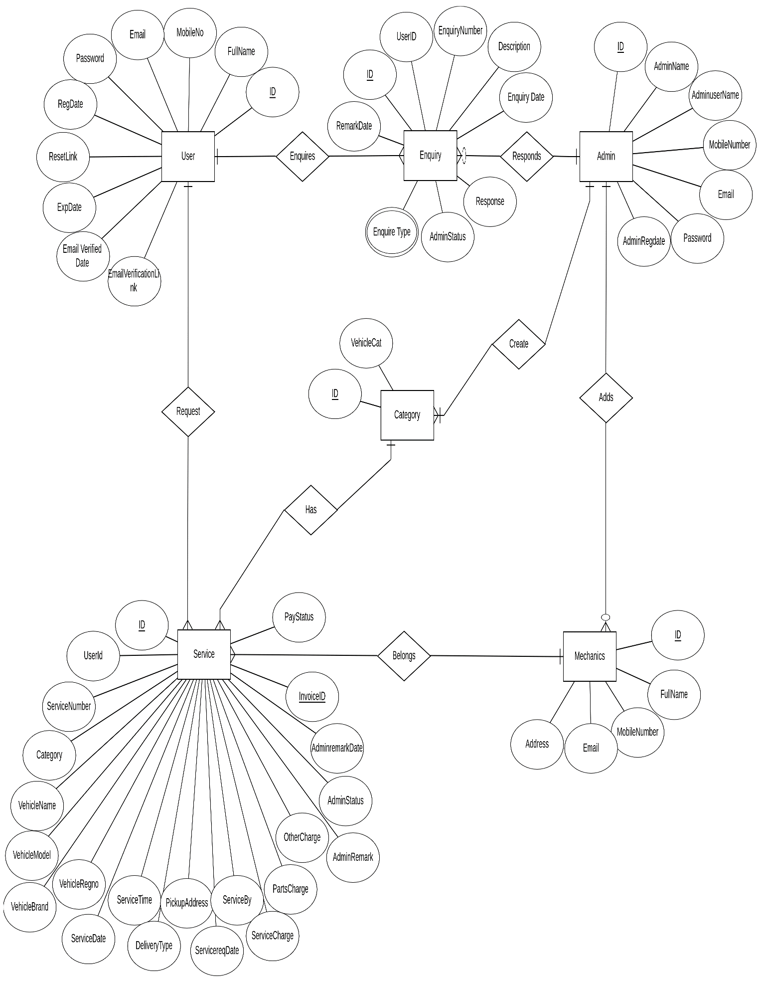

**Fig 1: Entity relationship diagram for Garage92**

**4.2 Activity diagrams4.2.1 User**

**4.2.1.1 Get appointment module**

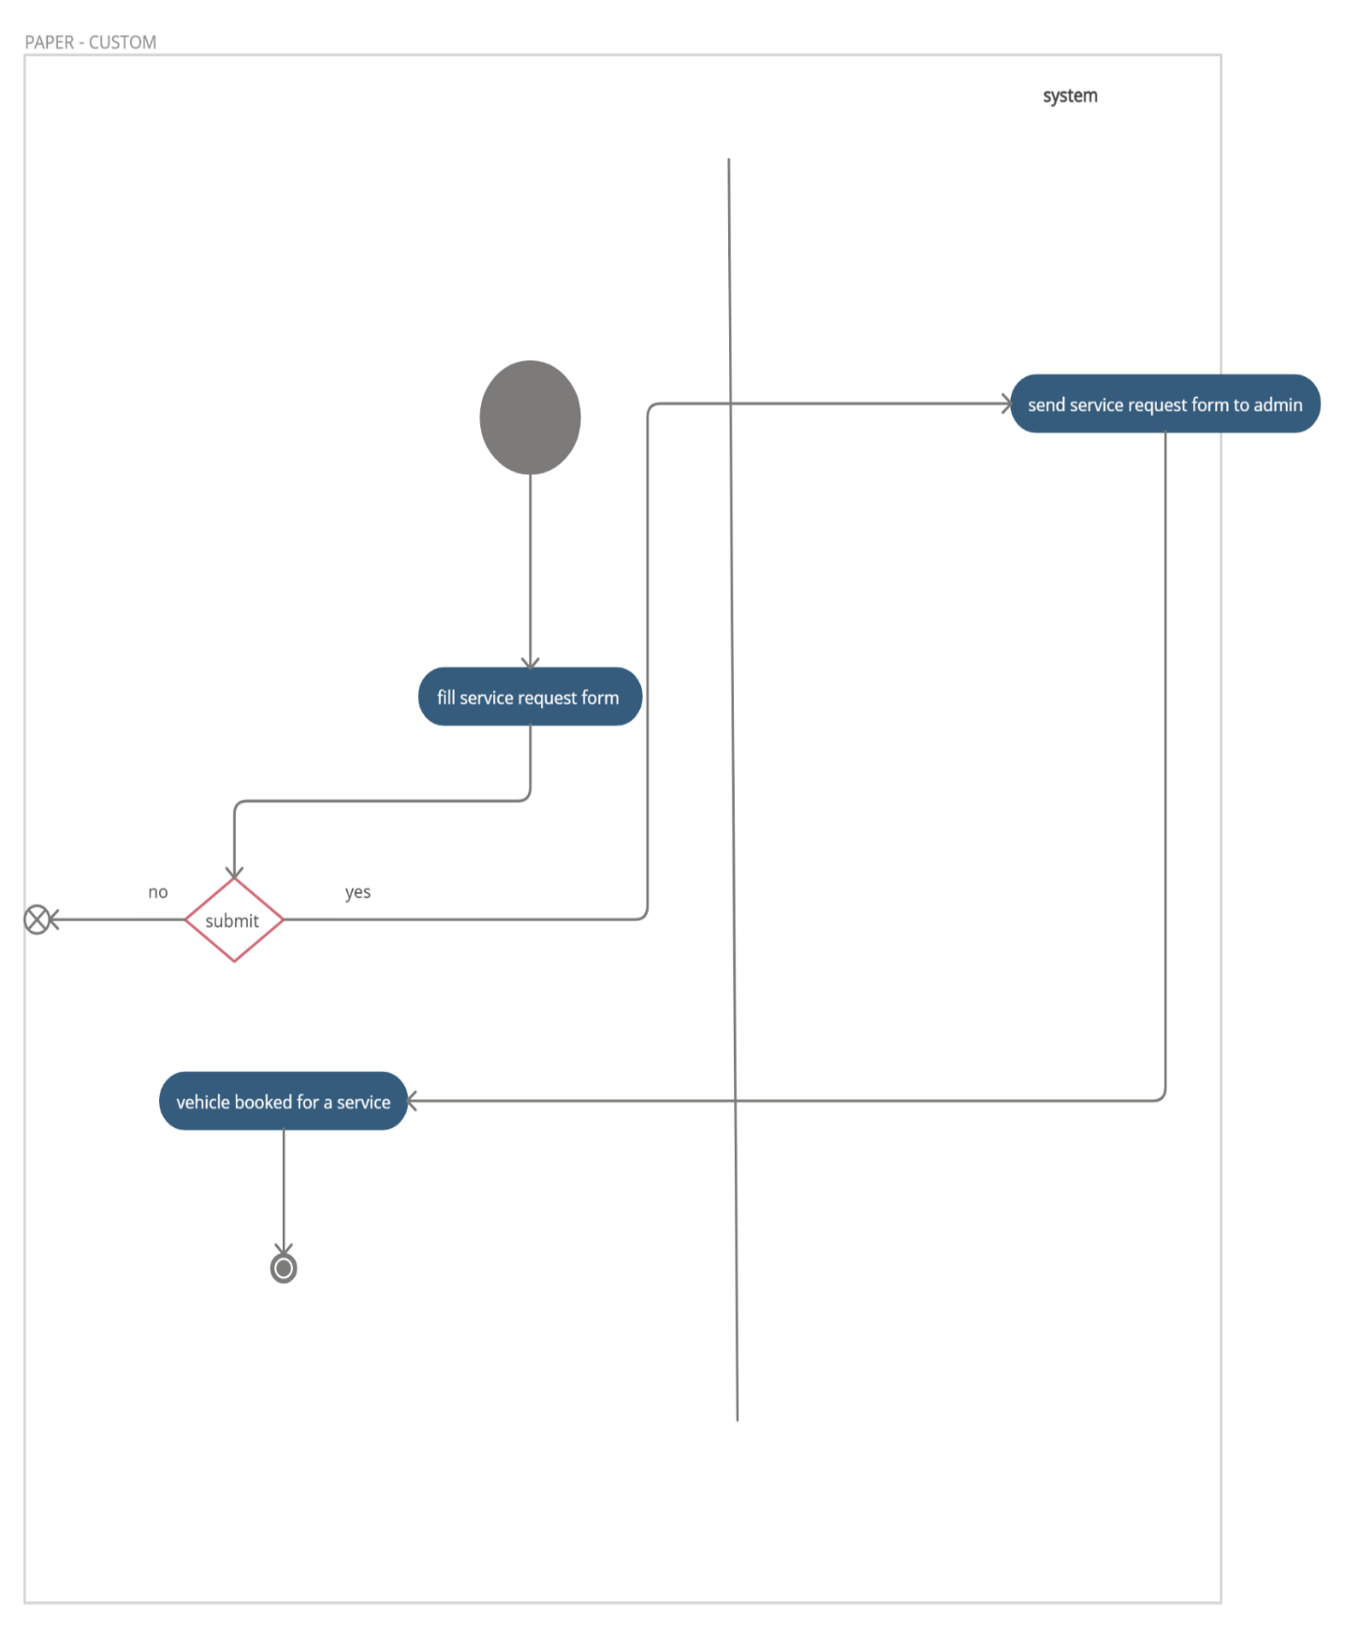

user

**Fig 2: Activity diagram for Get appointment module**

**4.2.1.2 Enquiry request module**

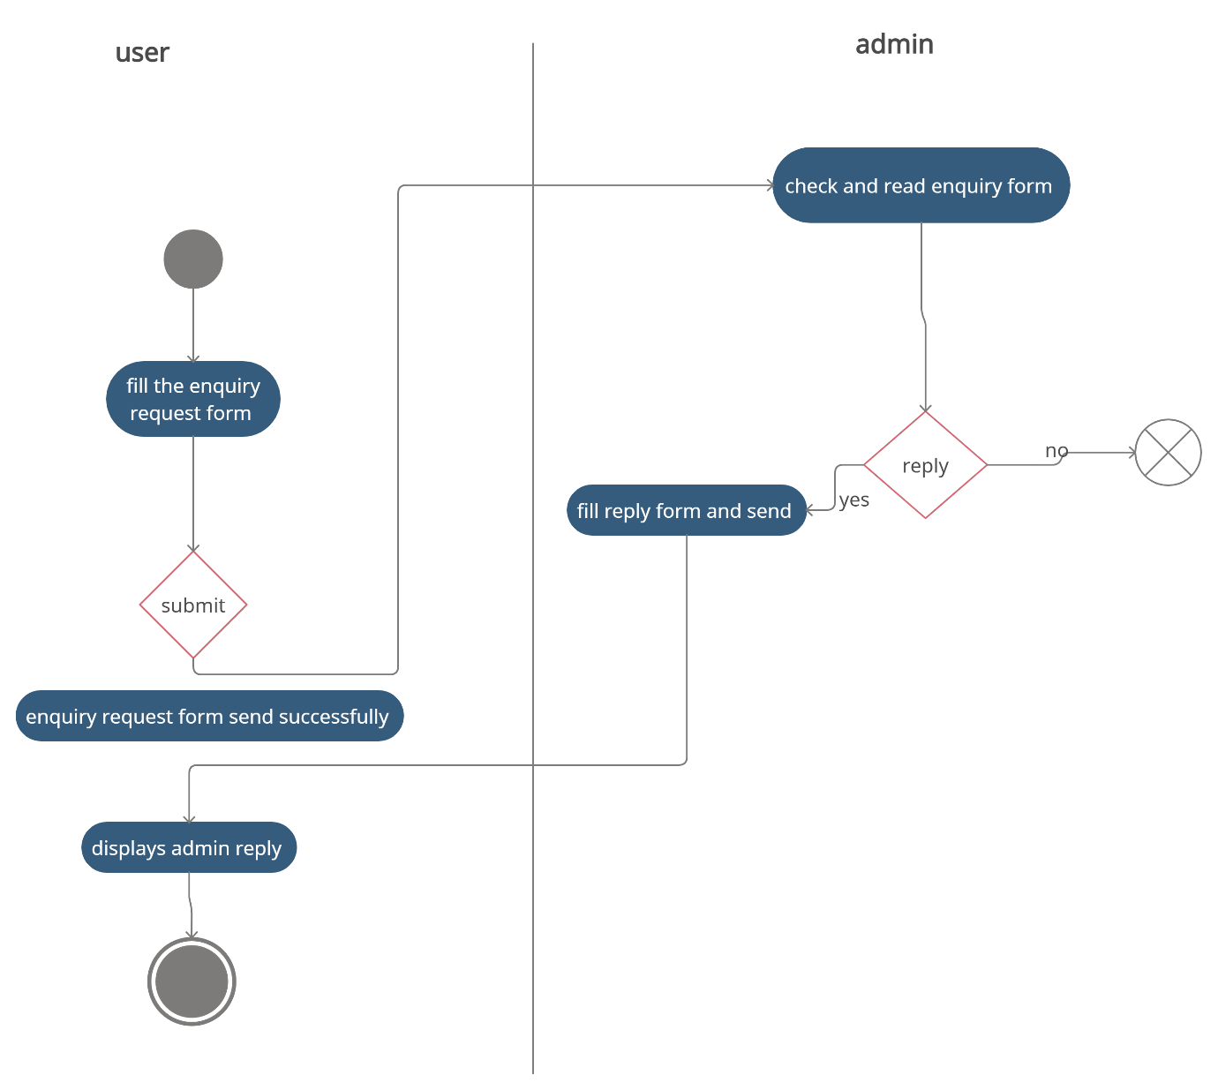

**Fig 3: Activity diagram for Enquiry request module**

**4.2.1.3 Forgot Password module**

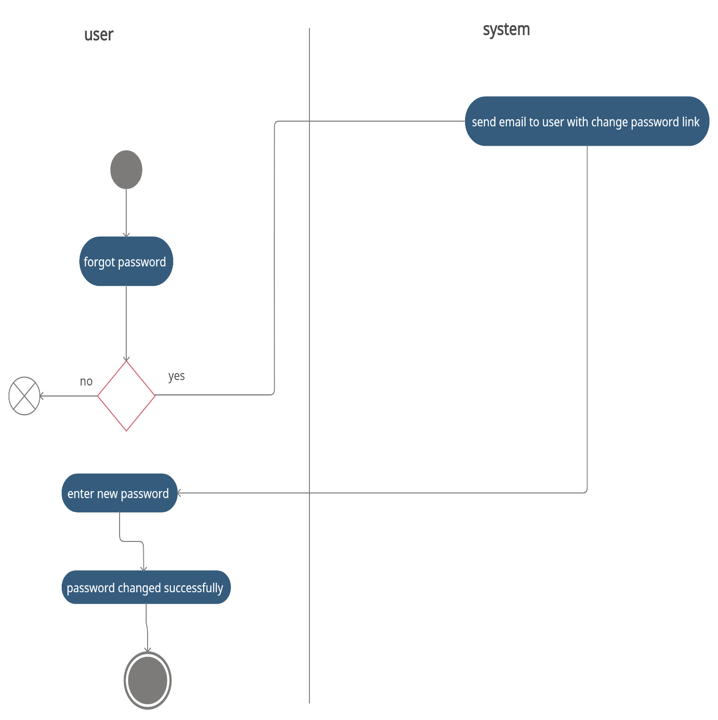

**Fig 4: Activity diagram for forgot Password module**

**4.2.1.4 User my profile module**

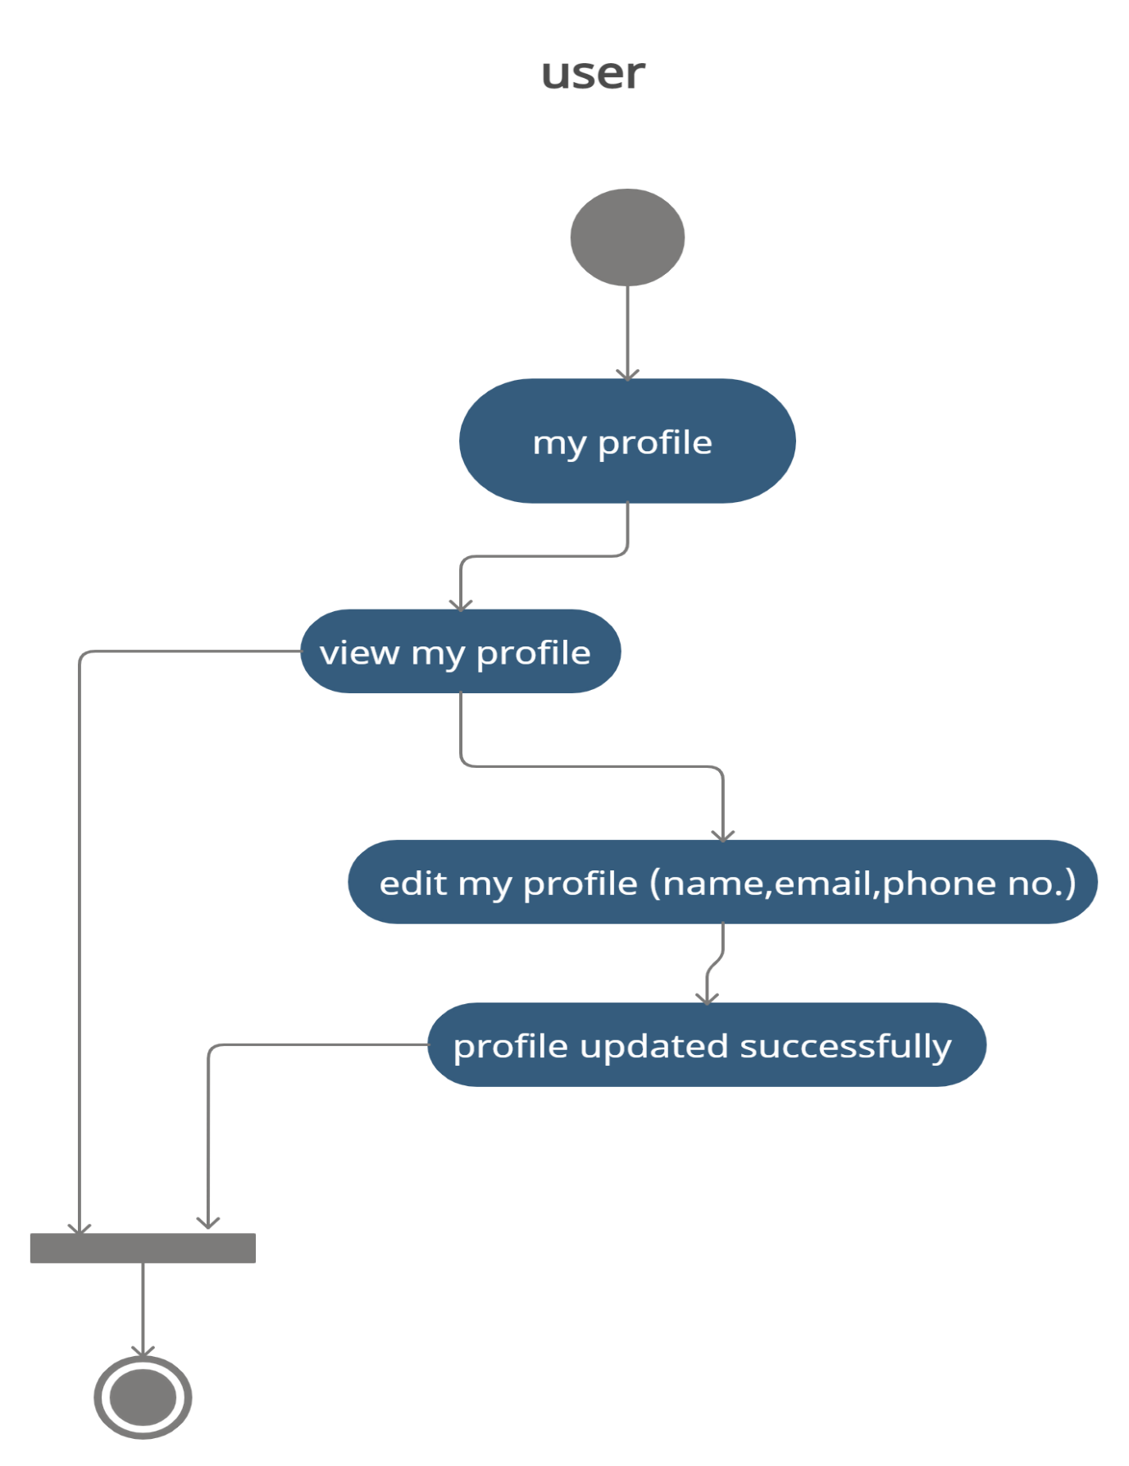**Fig 5: Activity diagram for User my profile module**

**4.2.1.5 User login/registration module**

****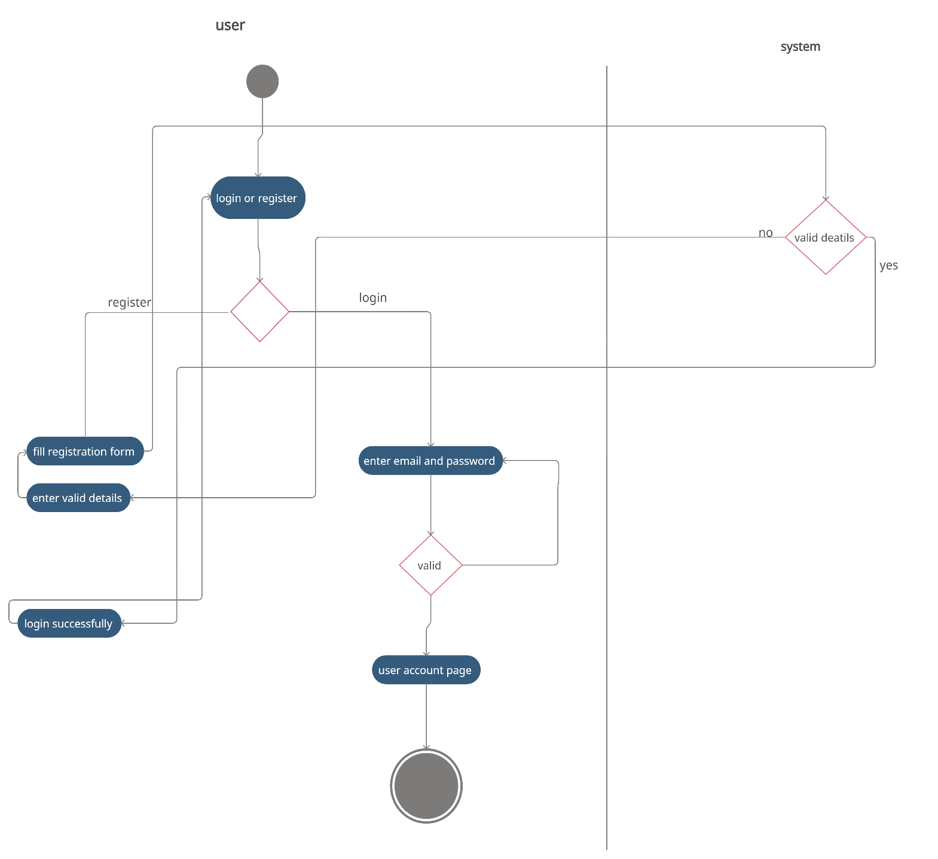

**Fig 6: Activity diagram for User login/registration module**

**4.2.1.6 User Change password**

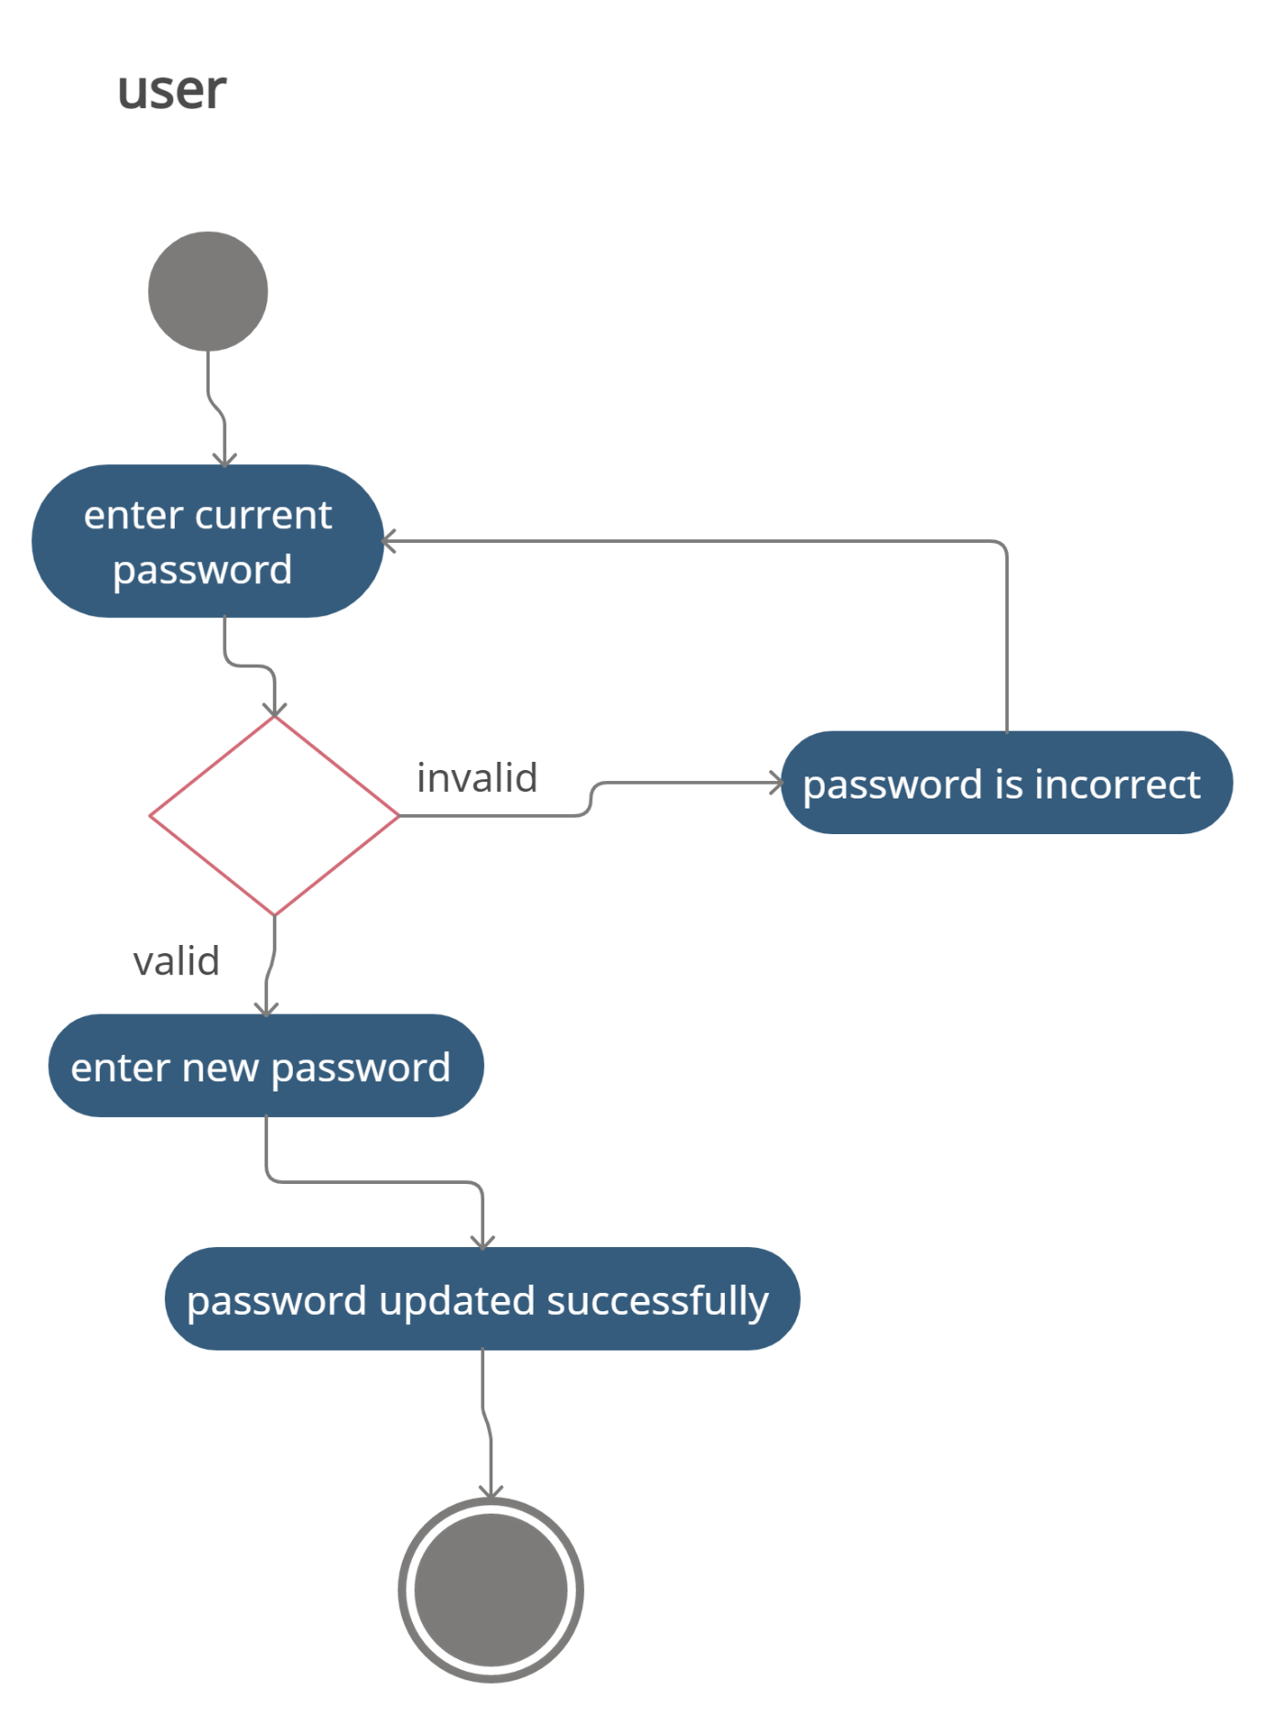

**Fig 7: Activity diagram for User Change password**

**4.2.2 Admin**

**4.2.2.1 Admin service request module**

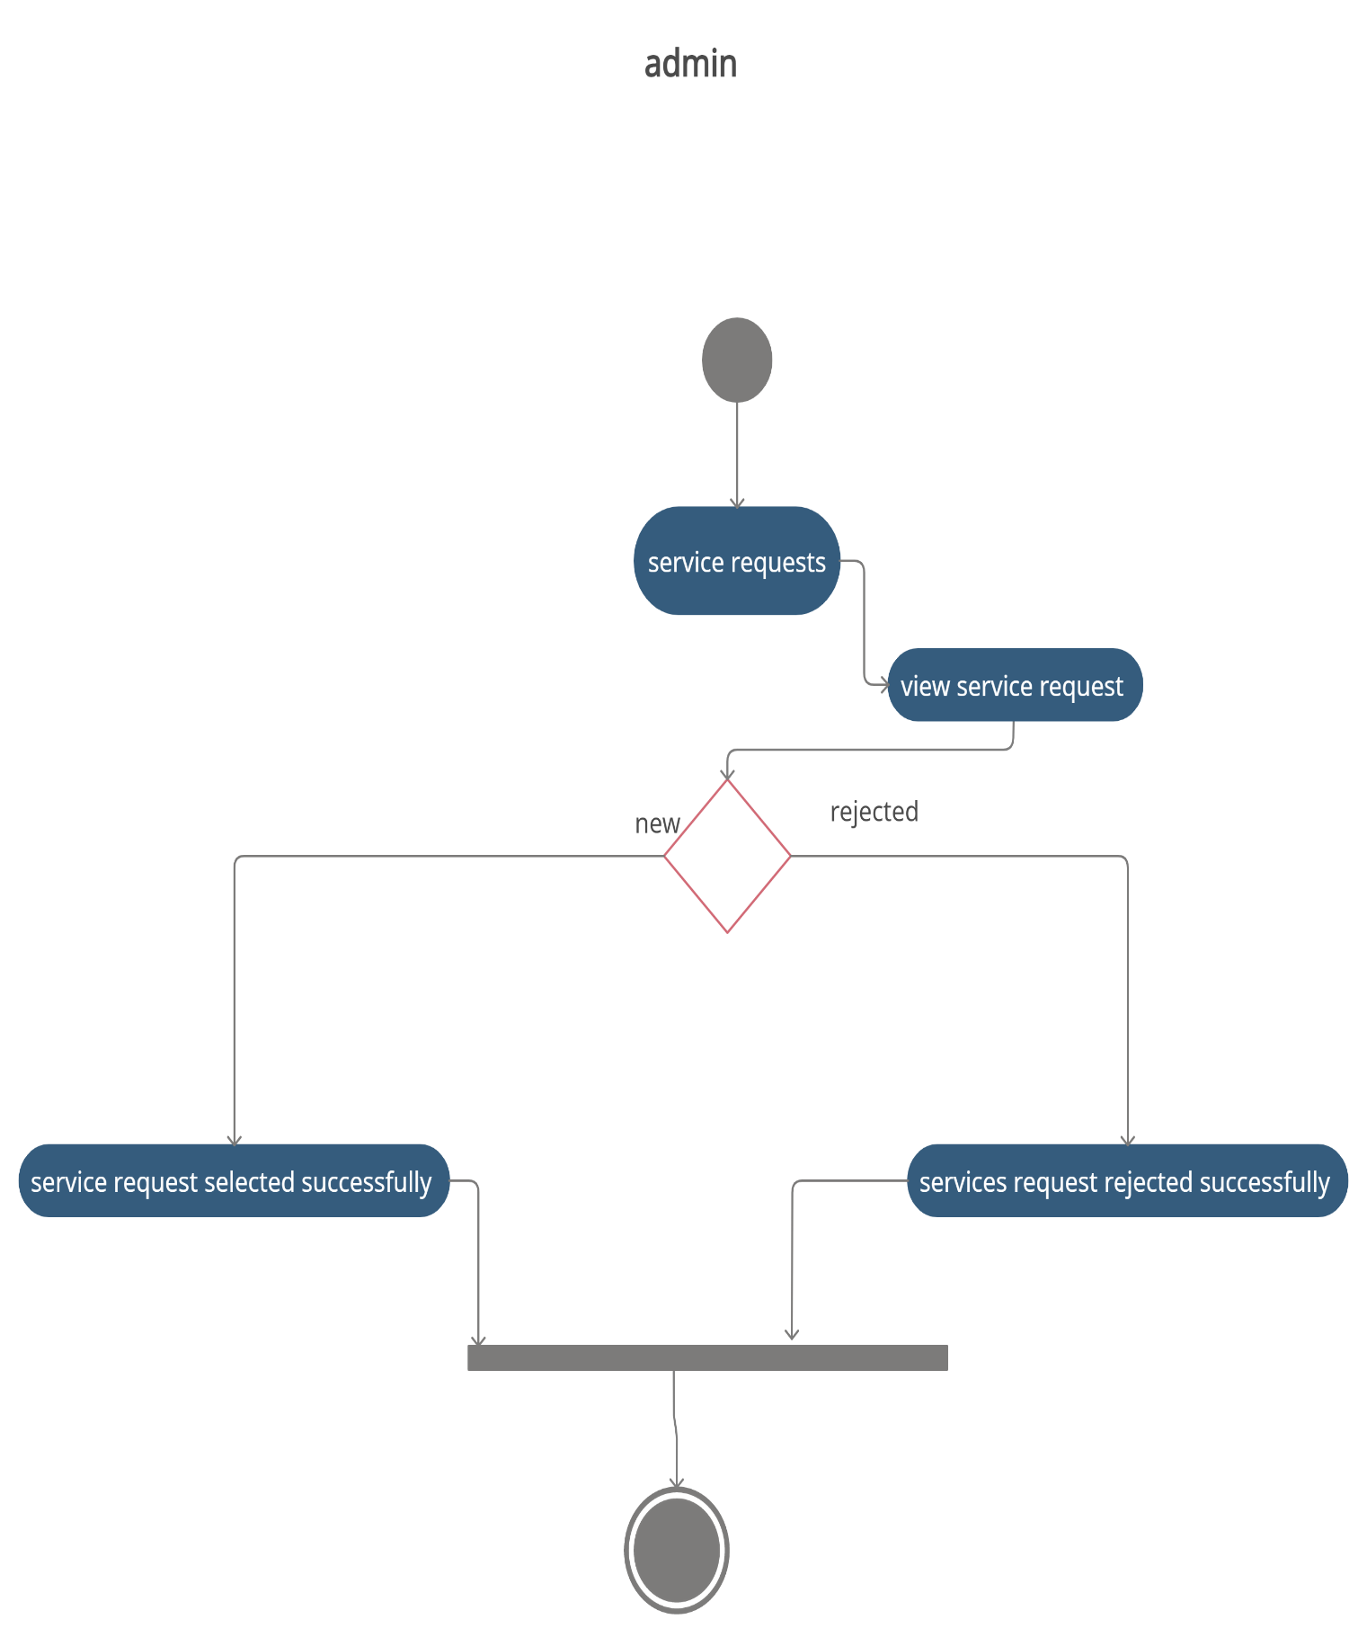

select

**Fig 8: Activity diagram for Admin service request module**

**4.2.2.2 Admin vehicle servicing module**

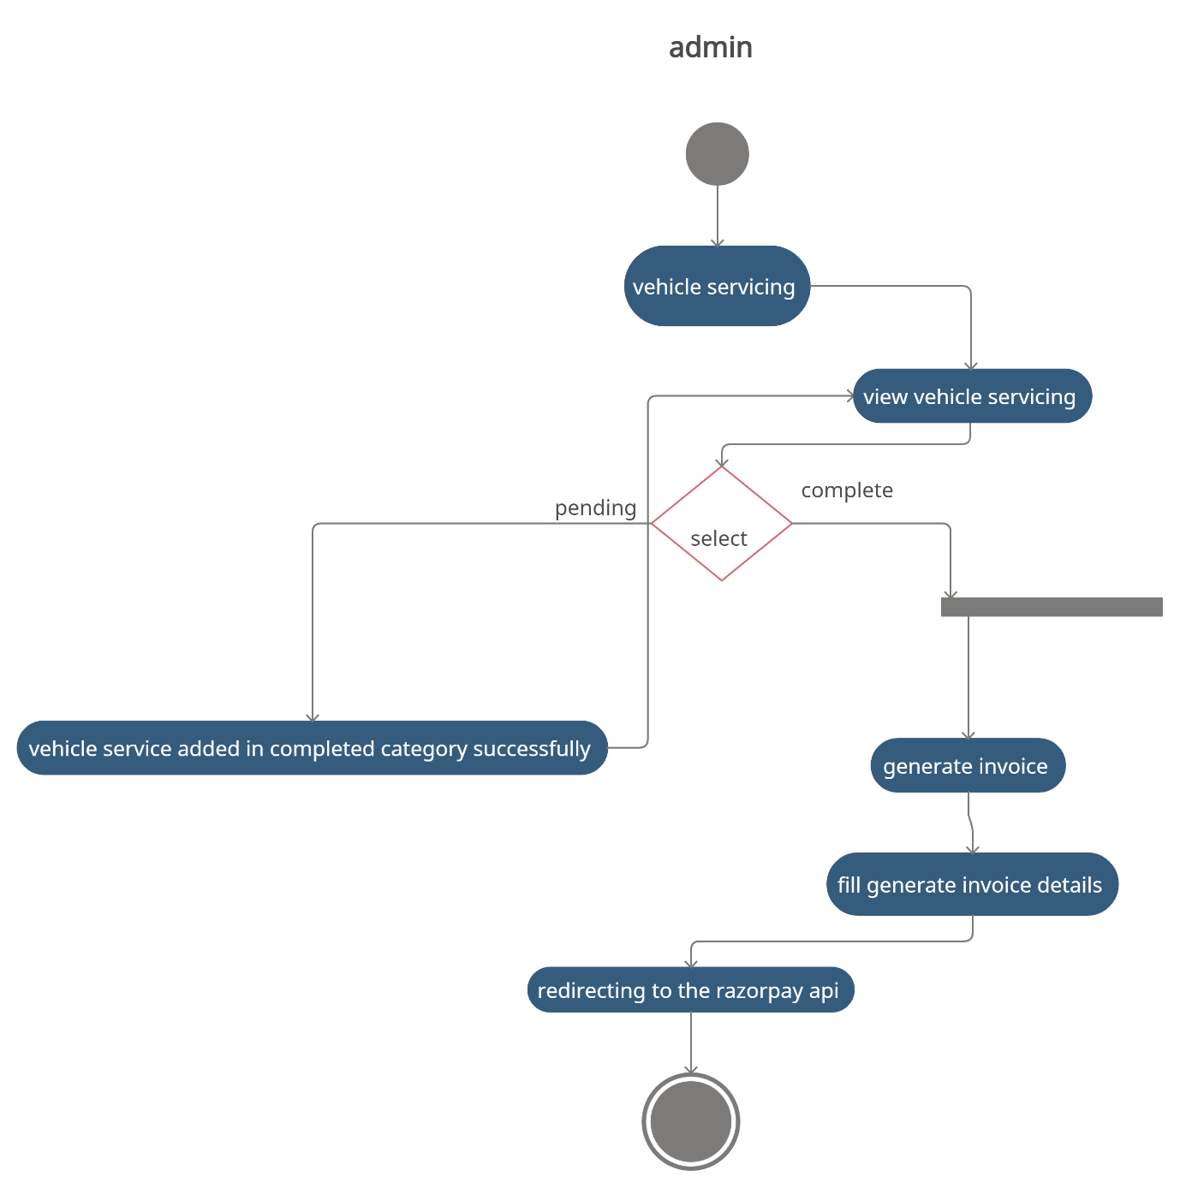

**Fig 9: Activity diagram for Admin vehicle servicing module**

**4.2.2.3 Admin enquiry requests**

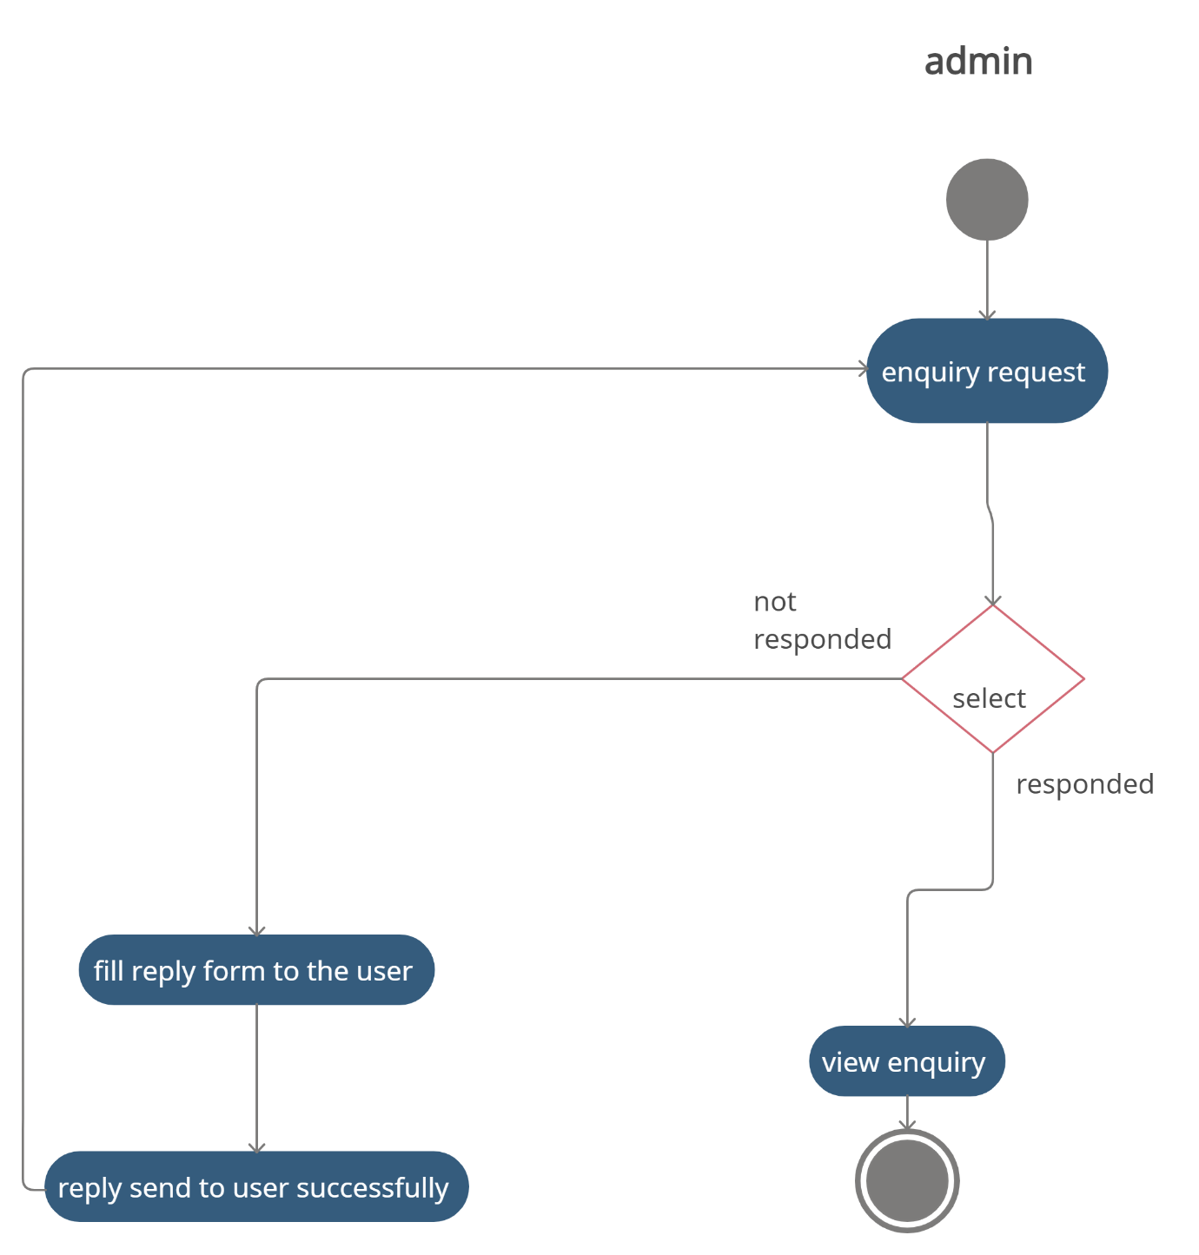

**Fig 10: Activity diagram for Admin enquiry requests**

**4.2.2.4 Admin mechanics module**

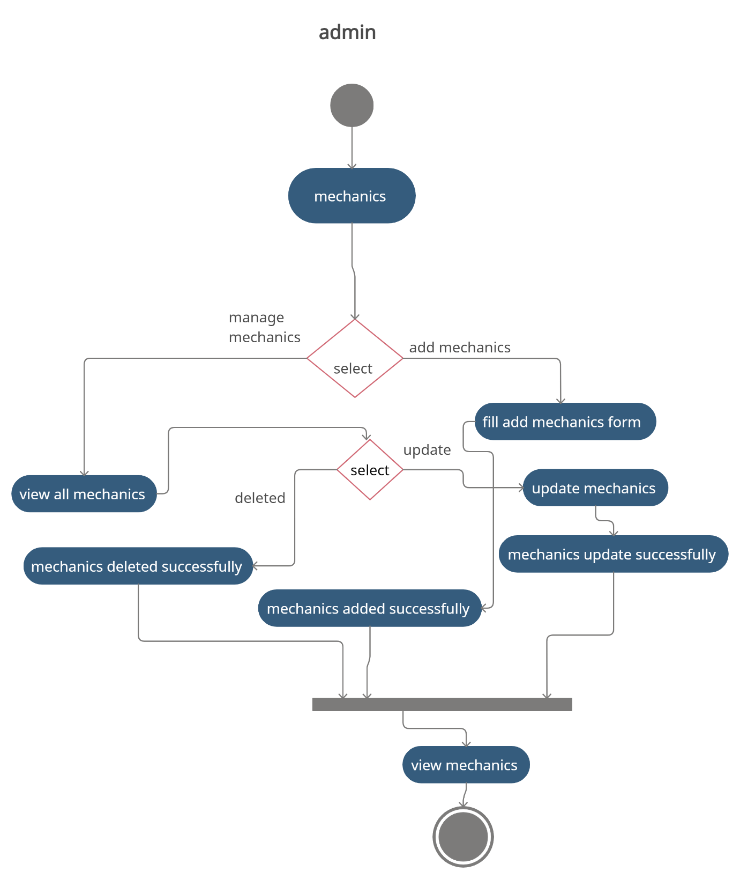

**Fig 11: Activity diagram for Admin mechanics module**

**4.2.2.5 Admin vehicle category module**

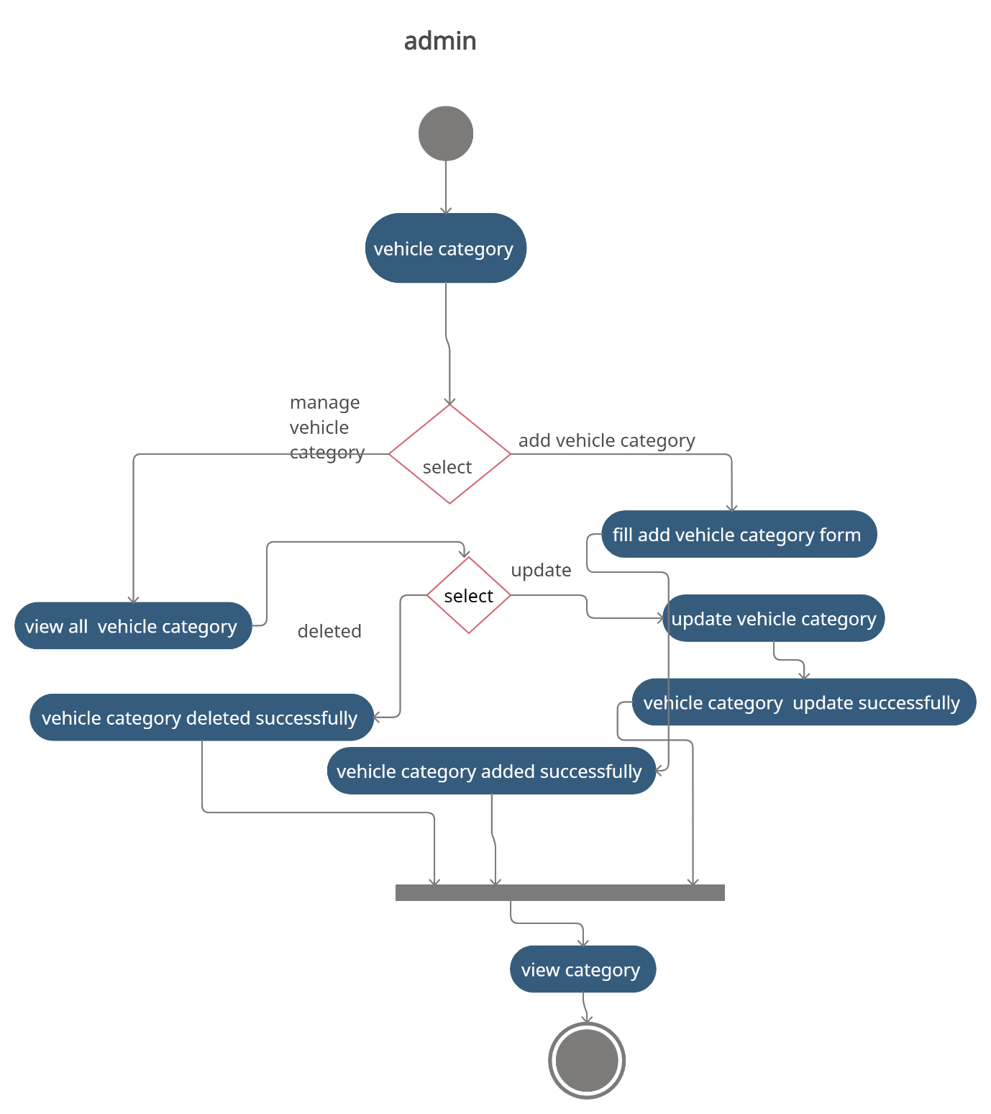

**Fig 12: Activity diagram for Admin vehicle category module**

**4.2.2.6 Admin generate invoice module**

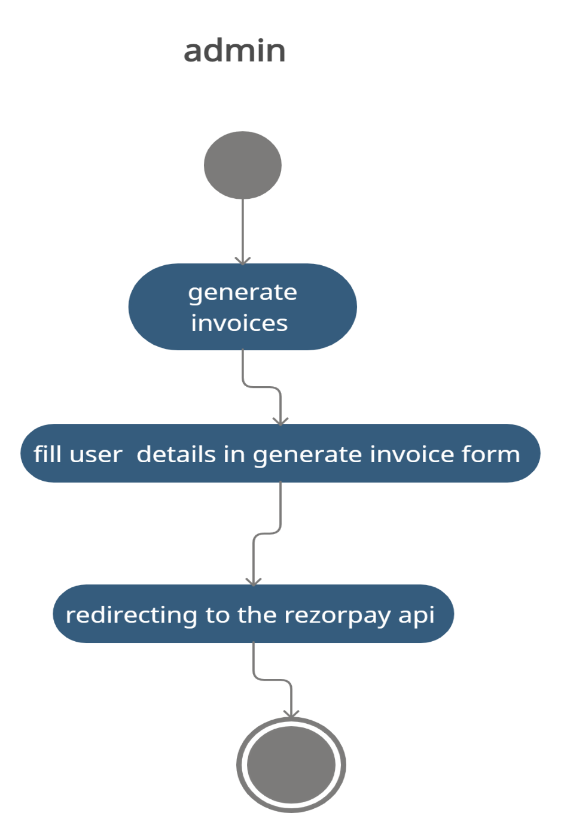

**Fig 13: Activity diagram for Admin Generates invoice module**

**4.2.2.7 Admin profile module**

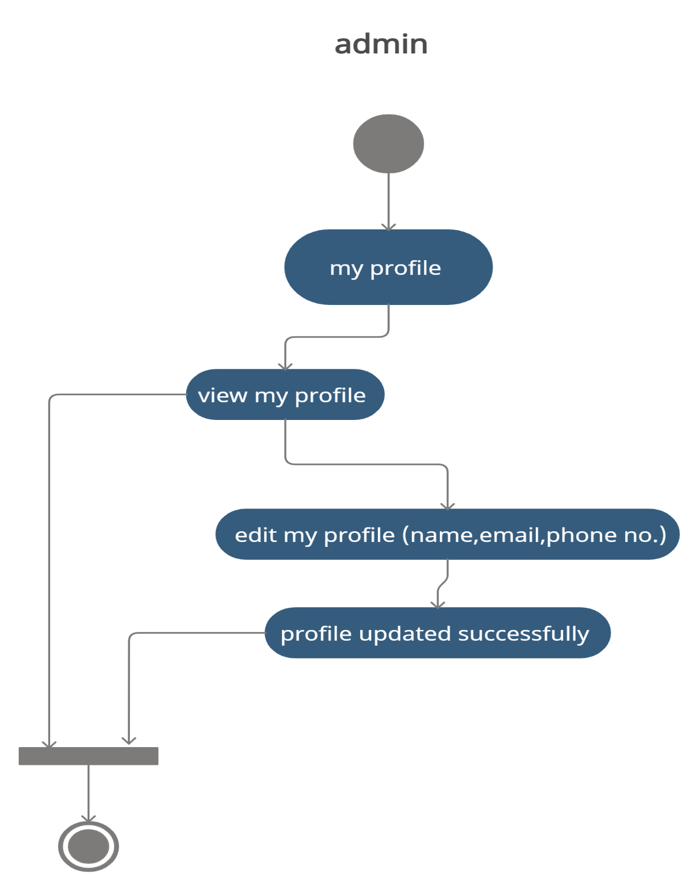

**Fig 14: Activity diagram for Admin profile module**

**4.2.2.8 Admin change password**

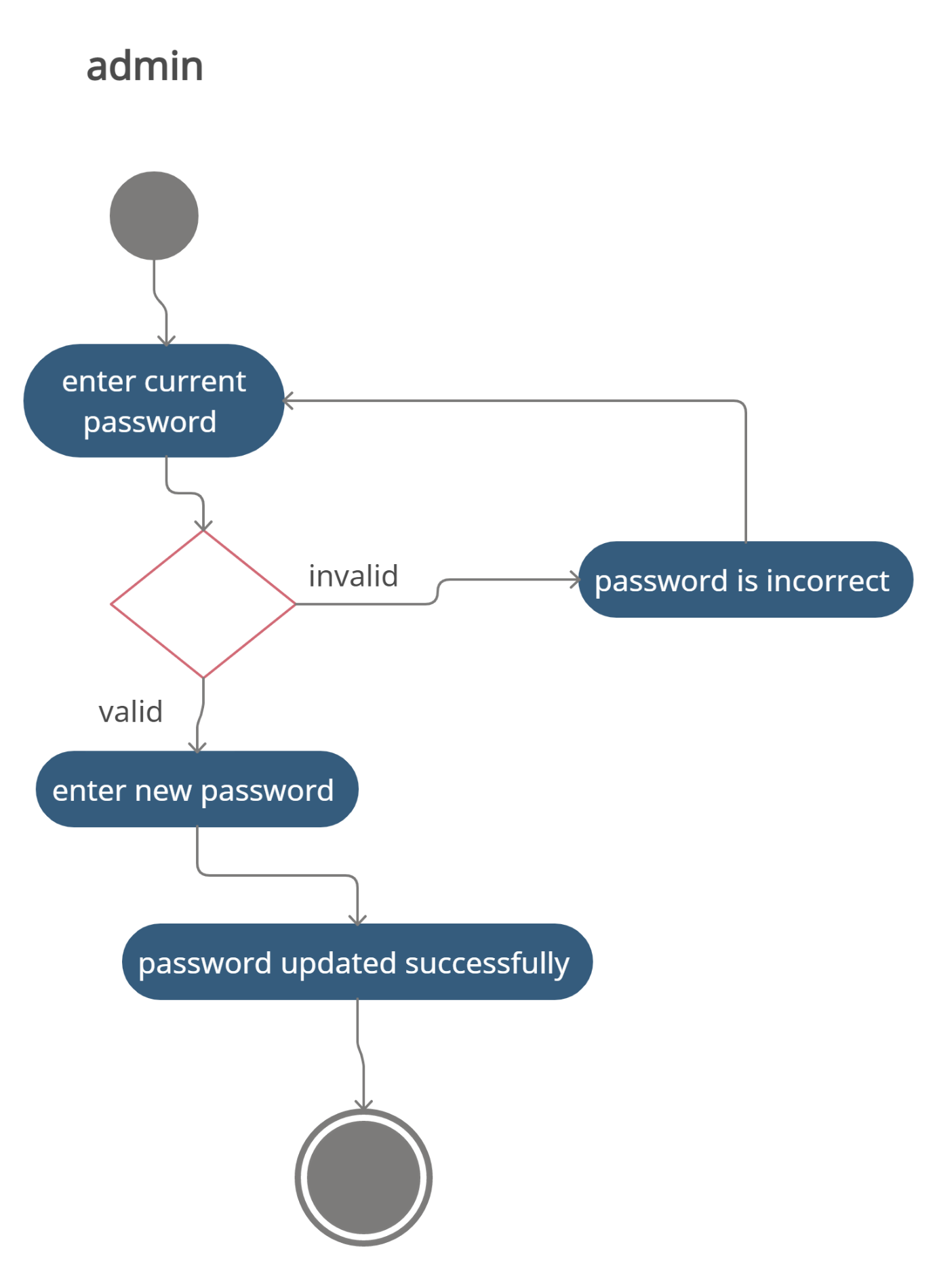

**Fig 15: Activity diagram for Admin change password**

**4.3 Class diagram**

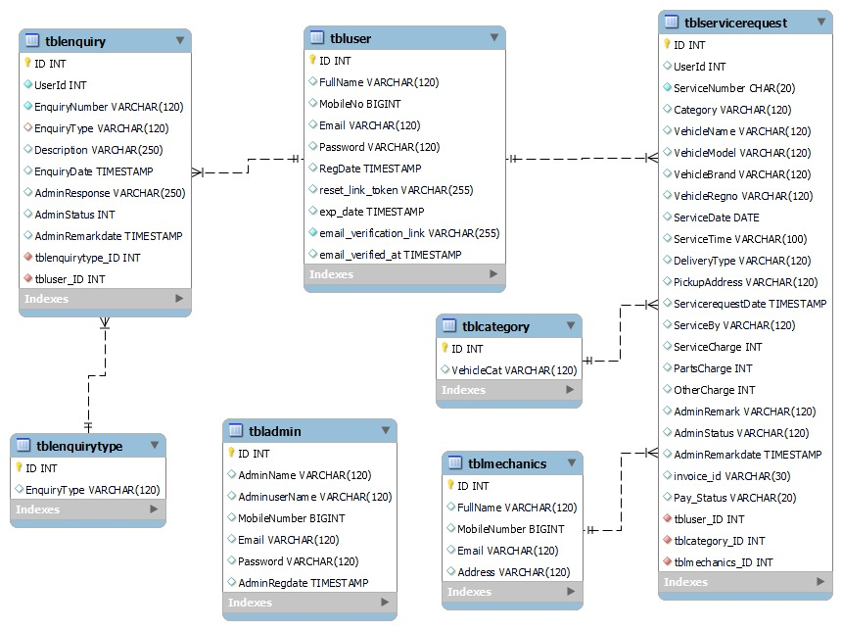

**Fig 16: Class diagram for Garage92**

**4.4 Use case diagram**

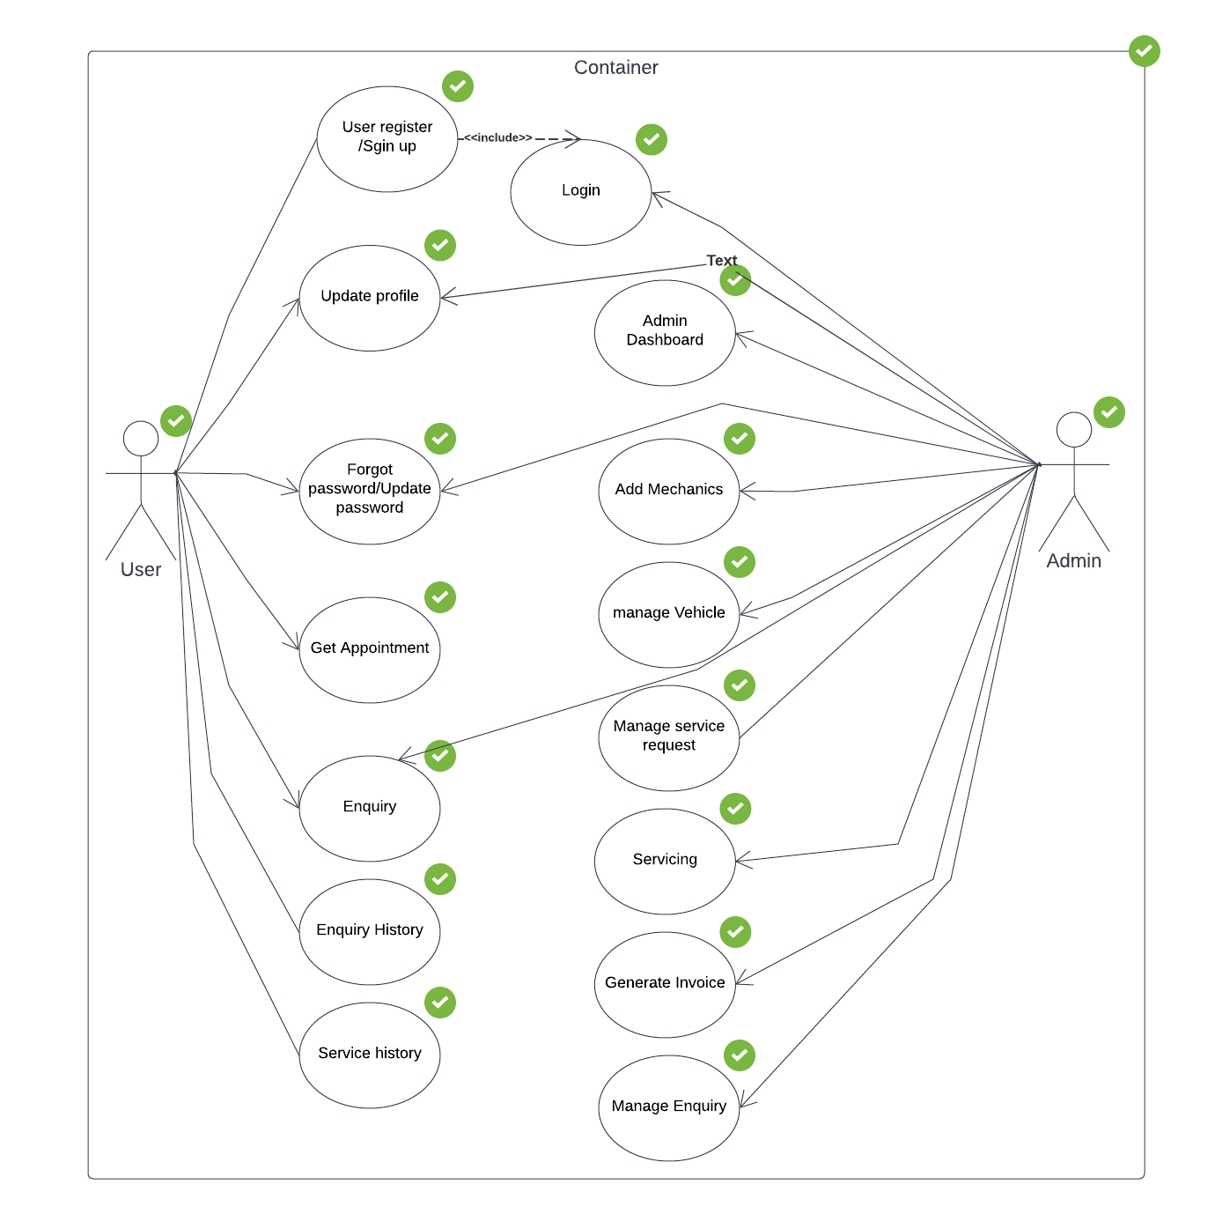

**Fig 17: Use Case Diagram for Garage92**

**CHAPTER 5**

**IMPLEMENTATION   
AND   
TOOL USED**

**5.1 Introduction**

A software implementation is the method of carrying out, execution, or practice of a plan, a method, or any design, idea, model, specification, standard or policy for doing something. Implementation is the action that must follow any preliminary thinking in order for something to actually happen.

**5.1.1 SDLC**

SDLC is a process followed for a software project, within a software organization. It consists of a detailed plan describing how to develop, maintain, replace and alter or enhance specific software. The life cycle defines a methodology for improving the quality of software and the overall development process.

   
**5.1.2 Incremental Model**  
Incremental Model is a process of software development where requirements are broken down into multiple standalone modules of software development life cycle. Incremental development is done in steps from analysis design, implementation, testing/verification, maintenance.  
Each iteration passes through the requirements, design, coding and testing phases. And each subsequent release of the system adds function to the previous release until all designed functionality has been implemented.

**5.2 Backend Software Tools**

**5.2.1 PHP**

PHP is a popular general-purpose scripting language that is especially suited to web development. It is Fast, flexible and pragmatic. We have used php for allowing web developers to create dynamic content and to interact with databases. PHP is known for its simplicity, speed, and flexibility — features which have made it a cornerstone in the web development world.

**5.2.1 MySQL**

MySQL is a relational database management system based on the Structured Query Language, which is the popular language for accessing and managing the records in the database. We have used MySQL to communicate with a database.

**5.3 Editing tool**

**5.3.1 Visual Studio Code**

Visual Studio Code is a code editor redefined and optimized for building and debugging modern web and cloud applications. Visual Studio Code is free and available on your favourite platform - Linux, macOS, and Windows. we have used visual studio code for a streamlined code editor with support for development operations like debugging, task running, and version control and for tools a developer needs for a quick code-build-debug cycle and leaves more complex workflows to fuller featured IDEs.

**5.4 Technologies used**

**5.4.1 Apache HTTP server**

Apache HTTP Server is a free and open-source web server that delivers web content through the internet. It is commonly referred to as Apache and after development, it quickly became the most popular HTTP client on the web. We have used Apache http server for accepting directory (HTTP) requests from Internet users and sending them their desired information in the form of files and Web pages.

**5.4.2 MySQL**

MySQL is an Oracle - hacked open-source relational database management system. (RDBMS) based on structured query language (SQL). MySQL runs on virtually all platforms, including Linux, UNIX and Windows. Although it can be used as a wide range of applications, MySQL is most often associated with web applications and online publishing. We have used MySQL to store all users, information, etc.

**5.4.3 Gantt Project**

Gantt Project is a free open-source Java based project management software. It features the most basic project management functions like a Gantt chart for project scheduling of tasks and doing resource management using resource load charts. It can only handle days, not hours. It has a number of reporting options (MS Project, HTML, PDF, Spreadsheets). We have used Gantt Project for planning and scheduling projects.

**5.5 Front End Tools**

**5.5.1 HTML5**

The Hypertext Markup Language or HTML is the standard markup language for documents designed to be displayed in a web browser. It can be assisted by technologies such as Cascading Style Sheets and scripting languages such as JavaScript. We have used it for the primary design and structure of a webpage. In our project we have used HTML 5

**5.5.2 CSS3**

Cascading Style Sheets is a style sheet language used for describing the presentation of a document written in a markup language such as HTML. CSS is a cornerstone technology of the World Wide Web, alongside HTML and JavaScript. We have used CSS for describing the presentation of Web pages, including colours, layout, and fonts.

**5.5.3 JavaScript ES6**

JavaScript, often abbreviated JS, is a programming language that is one of the core technologies of the World Wide Web, alongside HTML and CSS. Over 97% of websites use JavaScript on the client side for web page behaviour, often incorporating third-party libraries. We have used JavaScript for to creating dynamic and interactive web content. In our project we have used JavaScript EC6 version

**5.5.4 Bootstrap 5**

Bootstrap is a free and open-source CSS framework directed at responsive, mobile-first front-end web development. It contains HTML, CSS and JavaScript-based design templates for typography, forms, buttons, navigation, and other interface components. we have used bootstrap for to help you design websites faster and easier.

**5.6 Middleware and auxiliary tools used**

**5.6.1 Razorpay API**

You can use Razorpay APIs in two modes, Test and Live. The API keys are different for each mode. (In this project we have used test mode). Razorpay is the only converged payments solution company in India that allows your business to accept, process, and disburse payments via its product suite. With Razorpay, you have access to all payment modes, including credit and debit cards, UPI, and popular mobile wallets. We have used razorpay api (invoice API) for allowing businesses to accept, process and disburse payments.

**5.6.2 Gmail API**

The Gmail API is a RESTful API that can be used to access Gmail mailboxes and send mail. For most web applications the Gmail API is the best choice for authorized access to a user's Gmail data and is suitable for various applications, such as: Read-only mail extraction, indexing, and backup we have used Gmail API to access Gmail mailboxes and send mail to the user. In this we are using to send Email to the customers.

**CHAPTER 6**

**SOFTWARE TESTING   
AND   
DEPLOYMENT**

**Validation Test and System Integration Test Report**

**6.1 Introduction**

Testing is the process of evaluating a software to detect difference between given and expected output. Also, to access the feature and quality of the software. Testing is the process that should be done during the development process. In other words, testing is verification and validation process, where verification means to make sure the product satisfies the condition imposed at the start of the development phase and validation means to make sure the product satisfies the requirement at the development phase. Testing is one of the major areas wherein it becomes easy in understanding the behavior of the software created.

**6.2 Manual testing**

Manual Testing is a type of software testing in which test cases are executed manually by a tester without using any automated tools. The purpose of Manual Testing is to identify the bugs, issues, and defects in the software application. Manual software testing is the most primitive technique of all testing types and it helps to find critical bugs in the software application. with manual testing a testing manually conducts tests on the software by following a set of pre-defined test cases

**6.2.1 Unit testing**

Unit testing is a type of software testing where individual units or components of a software are tested. The purpose is to validate that each unit of the software code performs as expected. Unit Testing is done during the development (coding phase) of an application by the developers. Unit Tests isolate a section of code and verify its correctness. A unit may be an individual function, method, procedure, module, or object. In this project unit testing was done at every intermediate module level.

**6.2.2 Integration testing**

Integration testing is defined as a type of testing where software modules are integrated logically and tested as a group. A typical software project consists of multiple software modules, coded by different programmers. The purpose of this level of testing is to expose defects in the interaction between these software modules when they are integrated

Once all the module were developed and integrated together, integration testing was performed on this web application as a whole.

**6.3 Test cases for registration page**

|  |  |  |  |  |  |
| --- | --- | --- | --- | --- | --- |
| **Test Case ID** | **Description** | **Test Steps** | **Values** | **Expected Result** | **Result** |
| 6.3.1 | To verify if all the necessary fields are present on Registration page | 1) go to the login page  2)in below you will see sign up now text click on that |  | System should display Registration/Sign-up page should be display | Pass |
| 6.3.2 | Checking the functionality of sign-up button when all inputs or one of the inputs are empty | 1)go to the sign-up page  2)leave all inputs or one of the inputs are empty | Name:  Mobile number:  Email: -  Password:  Confirm password: | System should give Validation message as “Please fill out this field” | Pass |
| 6.3.3 | Checking the functionality of sign-up button when all inputs or one of the inputs are in invalid format | 1)go to the sign-up page  2)put all inputs or one of the inputs are in invalid format | Name:243ef | System should validate and give validation message as “only characters and whitespace are allowed” | Pass |
|  |  |  | Mobile  number:  cffcfcd | System should validate and give validation message as enter only digits and exact 10 digits phone number |  |
|  |  |  | Email: -deferred@. | System should validate and give validation message as ‘Invalid email format’ |  |
|  |  |  | Password :433dd  Confirm password: 433dd | System should validate and give validation message as More than 6 characters allowed” |  |
| 6.3.4 | Checking the functionality of sign-up button when password and confirm password dose not match | 1)go to the sign-up page  2)enter values password and confirm password different | Password :43  Confirm password: 433dd | System should give message as  password and confirm password dose not match | Pass |
| 6.3.5 | Checking the functionality of sign-up button when password and confirm password is valid | 1)go to the sign-up page  2)enter values password and confirm password valid | Password: omgorantiwar  Confirm password: omgorantiwar | System should create an account and redirect to the login page | Pass |

**6.4** **Test cases for login page**

|  |  |  |  |  |  |
| --- | --- | --- | --- | --- | --- |
| **Test Case ID** | **Description** | **Test Steps** | **Values** | **Expected Result** | **Result** |
| 6.4.1 | To verify if all the necessary requirements are present in login page | 1)Click on Login from the top right navbar |  | System should display Email and password input field should be there | Pass |
| 6.4.2 | Checking the functionality of login button when email or password or both is empty | 1)click on login  2)leave fields empty  3)click on login button | Email:  Password: | Validation message should be displayed  “Please enter email &password” | Pass |
| 6.4.3 | Checking the functionality of login button when email and password fields are in invalid format | 1)click on login  2)enter email and password invalid  3)click on login button | Email: jdudfb@gmail.com  Password: mhdmnrje | Validation message should be displayed “Invalid Email or Password” | Pass |
| 6.4.4 | Checking the functionality of login button when email and password fields are in valid format | 1)click on login  2)enter email and password in valid format  3)click on login button | Email: om@gmail.com  Password: 123qwerty |  | Pass |
| 6.4.5 | Checking the functionality of login button when user have account and enter valid account details | 1)click on login  2)enter email and password  3)click on login button | Email: -omgorantiwar @gmail.com  Password: -123qwerty | The user will be taken to the homepage | Pass |

**6.5 Test Cases for Forgot Password**

|  |  |  |  |  |  |
| --- | --- | --- | --- | --- | --- |
| Test Case ID | Description | Test Steps | values | Expected Result | Result |
| 6.5.1 | To verify if all the necessary fields are present on Forgot Password Page | 1)Click on Forgot Password on the log-in page |  | System should display Forgot Password Page | Pass |
| 6.5.2 | Checking the functionality of submit button when email put is empty | 1)Click on Forgot Password on Log-in page  2)leave email input field | Email: - | System should give Validation message as “Please fill out this field” | Pass |
| 6.5.3 | Checking the functionality of submit button when email is in invalid format | 1)Click on Forgot Password on Log-in page  2)enter invalid email | Email: -jhbvgw | System should give Validation message as please enter valid email | Pass |
| 6.5.4 | Checking the functionality of submit button when email is in valid format | 1)Click on Forgot Password on Log-in page  2)Enter valid email | Email: -om@gmail.com | System should send email for reset password link to the user | Pass |

**6.6 Test cases for reset password page**

|  |  |  |  |  |  |
| --- | --- | --- | --- | --- | --- |
| **Test Case ID** | **Description** | **Test Steps** | **values** | **Expected Result** | **Result** |
| 6.6.1 | To verify if all the necessary fields are present on reset password page | 1)click on email reset password link |  | System should display reset password page | Pass |
| 6.6.2 | Checking the functionality of change password button when password and change password is empty | 1)click on email reset password link  2)leave input field | Password:  Confirm password: | System should give Validation message as “Please fill out this field” | Pass |
| 6.6.3 | Checking the functionality of change password button when password and change password is different | 1)click on email reset password link  2) enter values password and confirm password different | Password :43  Confirm password: 433dd | System should give message as  password and confirm password dose not match | pass |
| 6.6.4 | Checking the functionality of change password button when password and change password is invalid | 1)click on email reset password link  2) enter values password and confirm password invalid | Password :43  Confirm password: 43 | System should validate and give validation message as More than 6 characters allowed” | Pass |
| 6.6.5 | Checking the functionality of change password button when password and change password is valid | 1)click on email reset password link  2) enter values password and confirm password valid | Password: omgorantiwar  Confirm password: omgorantiwar | System should change the password and redirect to the login page | Pass |

**6.7 Test cases for User navigation bar**

|  |  |  |  |  |
| --- | --- | --- | --- | --- |
| **Test Case ID** | **Description** | **Test Steps** | **Expected Result** | **Result** |
| 6.7.1 | To check if all the necessary navigation buttons are present on user navigation | 1)Login to user account | Home, About, Location, Get Appointment, Service history, enquiry and enquiry history will be display on the navigation bar | Pass |
| 6.7.2 | To check the functionality of user navigation if clicked on Home | Click on home | Homepage will be displayed | Pass |
| 6.7.3 | To check the functionality of user navigation if clicked on About | Click on About | About us page will be displayed | Pass |
| 6.7.4 | To check the functionality of user navigation if clicked on Location | Click on location | Location page will be displayed | Pass |
| 6.7.5 | To check the functionality of user navigation if clicked on Get Appointment | Click on get appointment | Get appointment page should be displayed with a book now button | Pass |
| 6.7.6 | To check the functionality of user navigation if clicked on user service history | Click on service history | Service history will be displayed | Pass |
| 6.7.7 | To check the functionality of user navigation if clicked on Enquiry | Click on enquiry | Enquiry page will be displayed with an enquiry form | Pass |
| 6.7.8 | To check the functionality of user navigation if clicked on Enquiry history | Click on enquiry history | Enquiry history page will be displayed | Pass |

**6.8 Test Cases for Update Profile**

|  |  |  |  |  |  |
| --- | --- | --- | --- | --- | --- |
| **Test Case ID** | **Description** | **Test Steps** |  | **Expected Result** | **Result** |
| 6.8.1 | To verify if all the necessary fields are present on Update Profile page | On the navigation bar click on user icon and click on my profile |  | Update profile page should be displayed | Pass |
| 6.8.2 | To check the functionality of Update Profile button when one of the fields or all is left empty | Leave any one or field empty and click on Update profile button | Name: -  Email: -  Phone number: - | System should give Validation message as  “Please fill out this field” | Pass |
| 6.8.3 | Checking the functionality of Update button with invalid details | Enter all fields with invalid details and click on update button | Name: -436$ | System should validate and give validation message as only characters are | Pass |
|  |  |  | Email: -huffv | System should validate and give validation message as please enter valid email |  |
|  |  |  | Phone number: -454 | System should validate and give validation message as enter only digits and exact 10 digits phone number |  |

**6.9 Test Cases for home page**

|  |  |  |  |  |
| --- | --- | --- | --- | --- |
| **Test Case ID** | **Description** | **Test Steps** | **Expected Result** | **Result** |
| 6.9.1 | To verify if all the necessary fields are present on Home Page | 1)visit garage 92 website | System should display home page | Pass |
| 6.9.2 | To check if all the necessary Content and images, services content with about us are present on home page | 2)View home Page | All Content should be displayed images, services content with about us are present on home page | Pass |

**6.10 Test Cases for About us Page**

|  |  |  |  |  |
| --- | --- | --- | --- | --- |
| **Test Case ID** | **Description** | **Test Steps** | **Expected Result** | **Result** |
| 6.10.1 | To check the functionality of learn more and about us button | 1)Click on learn more or about us button | About us page should be displayed | Pass |
| 6.10.2 | To verify if all the necessary content is present in about us page | 1)Click on learn more or about us button | System should display all the necessary content in about us page | Pass |

**6.11 Test Cases for location Page**

|  |  |  |  |  |
| --- | --- | --- | --- | --- |
| **Test Case ID** | **Description** | **Test Steps** | **Expected Result** | **Result** |
| 6.11.1 | To check the functionality of location button | 1)Click on location button | Location page should be displayed | Pass |
| 6.11.2 | To verify if location is present through google iframe location or not | 1)Click on location button | System should display google iframe location | Pass |
| 6.11.3 | To verify if all the necessary content is present in location page | 1)Click on location button | System should display all the necessary content in location page | Pass |

**6.12 Test Cases for enquiry page**

|  |  |  |  |  |  |
| --- | --- | --- | --- | --- | --- |
| **Test Case ID** | **Description** | **Test Steps** | **values** | **Expected Result** | **Result** |
| 6.12.1 | To verify if all the necessary fields are present on enquiry page | 1)Click enquiry page |  | System should display all the necessary fields on enquiry page | Pass |
| 6.12.2 | Checking the functionality of submit button when one of the enquiry type and description is empty or both | 1)Click enquiry page  2)leave enquiry type and description | Enquiry type: -  Description: - | System should give Validation message as “Please fill out this field” | Pass |
| 6.12.3 | Checking the functionality of submit button when enquiry type and description is not empty | 1)Click enquiry page  2)enter enquiry type and description | Enquiry type: -part related  Description: -test hello | System should send enquiry to admin and give alert message as Your enquiry has been sent successfully. | Pass |

**6.13 Test Cases for enquiry history page**

|  |  |  |  |  |
| --- | --- | --- | --- | --- |
| **Test Case ID** | **Description** | **Test Steps** | **Expected Result** | **Result** |
| 6.13.1 | To verify if all the necessary fields and all enquiry of user are present on enquiry history page (enquiry number enquiry date action) | 1)Click enquiry history page | System should display all the necessary fields and all enquiry of user on enquiry history page | Pass |
| 6.13.2 | Checking the functionality of view details of button of enquiry history page  button if all necessary details are showing | 1)Click enquiry page  2)click view details | The system should be displaying all the necessary details of  enquiry history page | Pass |
| 6.13.3 | Checking the functionality of admin response of enquiry history page when admin haven’t responded | 1)Click enquiry page  2)click view details | The system should be display message as no action taken yet | Pass |
| 6.13.4 | Checking the functionality of admin response of enquiry history page when admin has been response | 1)Click enquiry page  2)click view details | The system should be display admin response | Pass |

**6.14 Test Cases for service request form**

|  |  |  |  |  |  |
| --- | --- | --- | --- | --- | --- |
| **Test Case ID** | **Description** | **Test Steps** | **Values** | **Expected Result** | **Result** |
| 6.14.1 | To verify if all the necessary input fields are present in-service request form | 1)Click get appointment  2)click on book now |  | System should display all the necessary input fields in service request form | Pass |
| 6.14.2 | Checking the functionality of submit button when all or one of the input fields is empty | 1)Click get appointment  2)click on book now  3)leave all or one of the input fields  4)click on submit | Category:  Vehicle name:  Vehicle brand:  Vehicle model:  Vehicle registration number:  Service time:  Service date:  Delivery type: | System should give Validation message as “Please fill out this field” | Pass |
| 6.14.3 | Checking the functionality of submit button when vehicle name is invalid | 1)click on book now  2)enter invalid vehicle name  3)click on submit | Vehicle name: 4567@#$%^ | System should give Validation message as “only character is allowed” | Pass |
| 6.14.4 | Checking the functionality of submit button when vehicle brand is invalid | 1)click on book now  2)enter invalid vehicle brand  3)click on submit | Vehicle brand: 4567#$% | System should give Validation message as “only character is allowed” | Pass |
| 6.14.5 | Checking the functionality of submit button when Vehicle Registration Number is invalid | 1)click on book now  2)enter invalid Vehicle Registration Number  3)click on submit | Vehicle model: dcjker | System should give Validation message as “please enter valid Vehicle Registration Number” | Pass |
| 6.14.6 | Checking the functionality of submit button when service time is invalid | 1)click on book now  2)enter invalid service time  3)click on submit | Service time: 19:08 | System should give Validation message as “value should be before 18” | Pass |
| 6.14.7 | Checking the functionality of submit button when all input is valid | 1)click on book now  2)enter all input field in valid format  3)click on submit | Category: two-wheeler  Vehicle name: active  Vehicle brand: Honda  Vehicle model: 2017  Vehicle registration number: GA-07-AL-5498  Service time: 16:03  Service date: 4-05-2022  Delivery type: drop service | System should give alert message as your service request has been send successfully | Pass |

**6.15 Test Cases for service history page**

|  |  |  |  |  |
| --- | --- | --- | --- | --- |
| **Test Case ID** | **Description** | **Test Steps** | **Expected Result** | **Result** |
| 6.15.1 | To verify if all the necessary fields and all service request of user are present on service history page (category vehicle name service request date service status, status of payment) | 1)Click service history page | System should display all the necessary fields and all service request of user on service history page | Pass |
| 6.15.2 | Checking the functionality service status column when service is in pending stage | 1)Click service history page | The system should be display service status as pending | Pass |
| 6.15.3 | Checking the functionality of service status column when admin selected the service request | 1)Click service history page | The system should be display service status as selected | Pass |
| 6.15.4 | Checking the functionality of service status column when admin rejected the service request | 1)Click service history page | The system should be display service status as rejected | Pass |
| 6.15.5 | Checking the functionality of service status column when admin completed the service request | 1)Click service history page | The system should be display service status as rejected | Pass |
| 6.15.6 | Checking the functionality of view details of button of service history page  button if all necessary details are showing | 1)Click service history page  2)click on view details | The system should be displayed all the necessary details of  Service history page | Pass |
| 6.15.7 | Checking the functionality of status of payment column when user haven’t paid the service of vehicle | 1)Click service history page | The system should be displayed message as unpaid in status of payment column of service history page | Pass |
| 6.15.8 | Checking the functionality of status of payment column when user have been paid the service of vehicle | 1)Click service history page | The system should be displayed message as paid in status of payment column of service history page | Pass |
| 6.15.9 | Checking the functionality of admin remark, part charge, service charge, additional charge, total amount when service status is not completed | 1)Click service history page  2)click on view details | The system should display empty field of admin remark, part charge, service charge, additional charge, total amount | Pass |
| 6.15.10 | Checking the functionality of admin remark, part charge, service charge, additional charge, total amount when service status is completed | 1)Click service history page  2)click on view details | The system should display all the necessary details admin remark, part charge, service charge, additional charge, total amount | Pass |

**6.16 Test cases for logout**

|  |  |  |  |  |
| --- | --- | --- | --- | --- |
| **Test Case ID** | **Description** | **Test Steps** | **Expected Result** | **Result** |
| 6.16.1 | Checking the functionality of logout if admin can logout from user panel | 1)click on logout | The system should be display login page | Pass |

**6.17 Test Cases for admin Login page**

|  |  |  |  |  |  |
| --- | --- | --- | --- | --- | --- |
| **Test Case ID** | **Description** | **Test Steps** | **Values** | **Expected Result** | **Result** |
| 6.17.1 | checking the functionality of login input if when one of the fields is left empty or all | 1. leave blank input for password and username | username:  Password: | System should be validated and give validation message as “Please fill out this field” | Pass |
|  |  | 1. leave username input blank | username:  Password: ***** |  |  |
|  |  | 1. leave password input blank | username: Admin  Password: |  |  |
| 6.17.2 | To check Admin login to the system with invalid username or password | 1)enter invalid username | 1)username: jkshg  Password: ***** | Validation message should be displayed  “Invalid username or password” | Pass |
|  |  | 2)enter invalid password | 2)username: admin  Password: *********** |  |  |
|  |  | 3)enter username and password invalid both | 3)username: hdkdjc  Password: ******* |  |  |
| 6.17.3 | To check if Admin can login to the system with valid username and password | 1)enter valid username and password | 1)username: Admin  Password: ******* | The admin should get access to the dashboard | Pass |

**6.18 Test cases for Admin dashboard**

|  |  |  |  |  |
| --- | --- | --- | --- | --- |
| **Test Case ID** | **Description** | **Test Steps** | **Expected Result** | **Result** |
| 6.18.1 | To check if admin can view all detail of vehicle service in brief like total registered user, Total Enquiry, Total Mechanics and Total Services. | 1) login  2)in sidebar click on dashboard | System should be get display all the operation in dashboard | Pass |

**6.19 Test cases for Add Mechanics**

|  |  |  |  |  |  |
| --- | --- | --- | --- | --- | --- |
| **Test Case ID** | **Description** | **Test Steps** | **Values** | **Expected Result** | **Result** |
| 6.19.1 | Checking the functionality of add mechanic’s button  when one of the fields is left empty or all | 1)Leave any one field and fill the rest or leave all  2)Click on Update profile button | name:  email:  Phone:  Address: | Validation message should be displayed  “Please fill out this field” | Pass |
| 6.19.2 | Checking the validation of add mechanics input field of name and phone number when it is in invalid | 1)click on add mechanics  2)enter name or phone number in invalid format | 1)phone:45662  3435  2)name: @#$ | System should give validation message for name as “only characters allowed” and for phone number as “please enter valid phone number” | pass |
| 6.19.3 | Checking the validation of add mechanics email input when it’s in invalid format | 1)click on add mechanics  2)enter email in invalid format | 1)email: dfhg@gf.gfh | System should give validation message for email as “please enter valid email” | Pass |
| 6.19.4 | Checking the functionality of add mechanics button when name, phone number, email,address is in valid format | 1)add mechanics  2)enter details  3)click on add mechanics button | name: Om gorantiwar  email: Om gorantiwar  Phone :9511864023  Address: mala panjim goa | System should add the mechanic and give alert message as” Mechanic Details has been added.” | Pass |

**6.20 Test cases for Manage Mechanics**

|  |  |  |  |  |  |
| --- | --- | --- | --- | --- | --- |
| **Test Case ID** | **Description** | **Test Steps** | **Values** | **Expected Result** | **Result** |
| 6.20.1 | Checking the functionality of edit mechanic’s button | 1) click on manage mechanics  2)Click on edit |  | The admin should get access to edit mechanic page | Pass |
| 6.20.2 | Checking the functionality of delete mechanic’s button | 1) click on manage mechanics  2)Click on delete |  | The system should delete the mechanics and give alert message as “Mechanic Record deleted.” | pass |
| 6.20.3 | To verify if all the mechanics are present on manage mechanics page | 1) click on manage mechanics |  | System should be display all members of mechanic with edit and delete button | Pass |
| 6.20.4 | Checking the edit functionality of manage mechanics when inputs are in valid format | 1) click on manage mechanics  2)Click on edit  3)edit the mechanics  4)click on add | Mechanic Name: Savio  Mechanic Contact Number:9822338006  Mechanic Email: [harish@gmail.com](mailto:harish@gmail.com)  Mechanic Address: gh-67, sohna road haryana | The system  Should update mechanics and give message as ‘’Mechanics detail has been updated’’ | Pass |
| 6.20.5 | Checking the validation of email, phone number when its invalid format­ | 1)click on edit mechanics  2)enter name, email or phone number in invalid format | Mechanic Name: Savio123 | System should give validation message as only characters are allowed | Pass |
|  |  |  | Mechanic Contact Number:9822338 | System should give validation message as 10 digits are allowed |  |
|  |  |  | Mechanic Email: fbsjkgv | System should give validation message as please enter valid email |  |

**6.21 Test cases for Update mechanics**

|  |  |  |  |  |  |
| --- | --- | --- | --- | --- | --- |
| **Test Case ID** | **Description** | **Test Steps** | **Values** | **Expected Result** | **Result** |
| 6.21.1 | Checking the functionality of update mechanic’s button  when one of the fields is left empty or all | 1) manage mechanics  2)click on edit  3) leave one of the input fields or all  4)click on update button |  | System should be get display all the operation in dashboard | Pass |
| 6.21.2 | Checking the validation of update mechanics button when input field of name and phone number when it is in invalid | 1) manage mechanics  2)click on edit  3) enter name and phone in invalid format  4)click on update button | 1)phone:45662  3435  2)name: @#$ | System should give validation message for name as “only characters allowed ” and for phone number as “please enter valid phone number” | Pass |
| 6.21.3 | Checking the validation of update mechanics of email input when it’s in invalid format | 1) manage mechanics  2)click on edit  3) enter email in invalid format  4)click on update button | 1)email: - dfhg@gf.gfh | System should give validation message for email as “please enter valid email | Pass |
| 6.21.4 | Checking the functionality of update mechanics button when name, phone number, email, address is in valid format | 1) manage mechanics  2)click on edit  3) enter all details in valid format  4)click on update button | 1)name: Om gorantiwar  2)email: om gorantiwar  Phone :9511864023  Address: mala panjim goa | System should update the mechanic and give message as”Mechanic  Details has updated” | Pass |

**6.22 Test cases for add category(vehicle)**

|  |  |  |  |  |  |
| --- | --- | --- | --- | --- | --- |
| **Test Case ID** | **Description** | **Test Steps** | **Values** | **Expected Result** | **Result** |
| 6.22.1 | Checking the validation of add vehicle category input which allow only character when it’s in invalid format | 1) click on add category  2)enter digits or special character in category input | Category name :3245@# | The system should give validation message as "only characters allowed " | Pass |
| 6.22.2 | Checking the functionality of add category button when its in valid format | 1) click on add category  2)enter details  3) click on add | Category name: two-wheeler | The system should be added the category(vehicle) and give validation  message as  Category has been added successfully. | Pass |
| 6.22.3 | Checking the functionality of add category button when input is empty | 1) click on add category  2)leave input empty  3) click on add | Category name: - | System should be validated and give validation message as “Please fill out this field” | Pass |

**6.23 Test cases for manage category(vehicle)**

|  |  |  |  |  |
| --- | --- | --- | --- | --- |
| **Test Case ID** | **Description** | **Test Steps** | **Expected Result** | **Result** |
| 6.23.1 | To verify if all the vehicle category are present | 1) click on category  2)click manage category | System should be displayed the all-vehicle category " | Pass |
| 6.23.2 | Checking the functionality of delete category button | 1) click on manage category  2) click on delete button | The system should be delete the vehicle category and give validation message as “Mechanic Record deleted.” | Pass |
| 6.23.3 | Checking the functionality of edit category button | 1) click on manage category  2) click on edit | The admin should get access to edit category(vehicle) page and display the edit-category page | Pass |

**6.24 Test cases for edit category**

|  |  |  |  |  |  |
| --- | --- | --- | --- | --- | --- |
| **Test Case ID** | **Description** | **Test Steps** | **Values** | **Expected Result** | **Result** |
| 6.24.1 | Checking the validation of edit vehicle category input which allow only character when it’s in invalid format | 1)click on vehicle category  2)click on manage category  3) click on edit  4)enter invalid details  5)click on edit | Category name :3245@# | The system should give message as "only characters allowed " | Pass |
| 6.24.2 | Checking the functionality of edit category button when it’s in valid format | 1)click on vehicle category  2)click on manage category  3) click on edit  4)enter valid details  5)click on edit | Category name: two-wheeler | The system should be update the category give message as “Category has been update.” | Pass |

**6.25 Test cases for new service request**

|  |  |  |  |  |  |
| --- | --- | --- | --- | --- | --- |
| **Test Case ID** | **Description** | **Test Steps** | **Values** | **Expected Result** | **Result** |
| 6.25.1 | To verify if all the necessary fields are present on in new service request page | 1)click on service request  2)click on new |  | The system be displayed all new service request information | Pass |
| 6.25.2 | Checking the functionality of view details of new service request button if all necessary details are showing | 1)click on service request  2)click on new  3)click on view details |  | The system should be displayed all the necessary details of  New service request | Pass |
| 6.25.3 | Checking the functionality of service status if admin cancelled the new service request | 1)click on view details  2) click on cancelled  3) submit | Service status: cancelled | System should be validated and displayed the message as’’ status has been updated’’ and in user service history page system should be update the service status as rejected | Pass |
| 6.25.4 | Checking the functionality of service status if admin select the new service request | 1)click on view details  2) click on select  3)submit | Service status: selected | System should be validated and displayed the message as’’ status has been updated’’ and in user service history page system should be update the service status as selected | Pass |
| 6.25.5 | Checking the functionality of service status if admin didn’t select any service status when default value is selected | 1)click on view details  2)submit | Service status: -selected | System should be validated and displayed the message as “Please select out this field” | Pass |

**6.26 Test cases for rejected services**

|  |  |  |  |  |
| --- | --- | --- | --- | --- |
| **Test Case ID** | **Description** | **Test Steps** | **Expected Result** | **Result** |
| 6.26.1 | To verify if all the rejected service request are present on rejected services page | 1)click on services request  2)click on rejected | System should be showing all rejected services | Pass |
| 6.26.2 | Checking the functionality of view details button of rejected services if all necessary details are showing | 1)click on service request  2)click on rejected  3)click on view details | The system should be displayed all the necessary details of rejected service request | Pass |

**6.27 Test cases for servicing (pending)**

|  |  |  |  |  |  |
| --- | --- | --- | --- | --- | --- |
| **Test Case ID** | **Description** | **Test Steps** | **Values** | **Expected Result** | **Result** |
| 6.27.1 | To verify if all the selected service request are present on pending services page | 1)click on servicing  2)click on pending |  | The system be displayed all new pending services | Pass |
| 6.27.2 | Checking the functionality of view details button of pending service if all necessary details are showing including input felids (service by, addition charges, part charge, service charge, admin remark) | 1)click on servicing  2)click on pending  3)click on view details |  | The system should be display all the necessary details of  pending services with input fields | Pass |
| 6.27.3 | Checking the validation of input field of service, part charge and additional charge when format is invalid (which is only digits allowed) | 1)click on view details  2) enter invalid details of service charge part charge additional charged  3)click on service completed | Service charge: @#$  Part charge: -duhyg  Additional charge: -hgv | System should be given validation message as “only digits are allowed “ | Pass |
| 6.27.4 | Checking the validation of service charge if service charge input is empty | 1)click on view details  2) leave input field of service charge  3)click on service completed | Service charge: | System should be display the validation message as “Please select out this field” | Pass |
| 6.27.5 | Checking the validation of select and admin remark filed of service by if admin not selected the mechanics or filled the input | 1)click on view details  2) leave admin remark and select drop down  3)click on service completed | Checkbox:  Service by: | The system should be given validation message as for admin remark “Please select out this field” for service by as please select item in the list | Pass |
| 6.27.6 | Checking the validation of input field of admin remark, service by, service, part charge and additional charge when it’s not empty and format is valid | 1)click on view details  2) enter details  3)click on service completed | Admin remark: test hello  Service by: select Shanaya, Savio  Service charge:1500  Part charge: 300  Additional charge: 40 | System should be sent the email to the user for service completion  and give alert massage as email has sent and service status should be changed as completed | Pass |

**6.28 Test cases for servicing (completed)**

|  |  |  |  |  |
| --- | --- | --- | --- | --- |
| **Test Case ID** | **Description** | **Test Steps** | **Expected Result** | **Result** |
| 6.28.1 | To verify if all the completed vehicle services are present on completed services page | 1)click on servicing  2)click on completed | System should be showing all completed services | Pass |
| 6.28.2 | Checking the functionality of view details button of pending service if all necessary details are showing or not | 1)click on servicing  2)click on completed  3)click on view details | The system should be displayed all the necessary details of completed service request | Pass |
| 6.28.3 | Checking the functionality of view service page weather admin can generate voice by clicking button on generate voice | 1)click on servicing  2)click on completed  3)click on view details  4)click on generate voice | The admin should get access to the invoice page | Pass |
| 6.28.4 | Checking the functionality of view service page weather if user has paid service, then it’s should not be show the generate voice button and | 1)click on servicing  2)click on completed  3)click on view details | The system should not be show the generate voice button | Pass |
| 6.28.5 | Checking the functionality of generate invoice button if admin can access to generate invoice page | 1)click on servicing  2)click on completed services  3) view details  4) click on generate invoices | The system should be display the  generate invoice page | Pass |
| 6.28.6 | Checking the functionality of generate invoices if all details of users (includes receivers information invoice details and amount of services) are automatically loaded in generate invoice page | 1) view details  2) click on generate invoices | The system should be load all the necessary details of  User services(receivers information invoice details and amount of services) | Pass |
| 6.28.7 | Checking the functionality of create invoice button in generate invoice page | 1. click on generate invoices 2. click on create | The system should be display the message as “invoice created successfully” and should be sent invoice email to the user | Pass |
| 6.28.8 | Checking the functionality of invoice id and status of view services(completed) when user has paid the service of vehicle | 1)click on servicing  2)completed | The system should be display the invoice id and status in the service completed page | Pass |

**6.29 Test cases for invoices**

|  |  |  |  |  |
| --- | --- | --- | --- | --- |
| **Test Case ID** | **Description** | **Test Steps** | **Expected Result** | **Result** |
| 6.29.1 | Checking the functionality of generate invoice button if admin can access to generate invoice page | 1)click on servicing  2)click on completed services  3) view details  4) click on generate invoices | The system should be displayed generate invoice page | Pass |
| 6.29.2 | Checking the functionality of generate invoices if all details of users (including amount of services) are automatically loaded in generate invoice page | 1) view details  2) click on generate invoices | The system should be load all the necessary details of  User services (RECEIVER (BILL TO) INFORMATION, phone no., email) | Pass |
| 6.29.3 | Checking the functionality of create button in generate invoice page | 1)click on generate invoice  2)click on create | System should be redirecting to razorpay(invoice) api and give alert message as “Invoice is Successfully Generated” | Pass |
| 6.29.4 | Checking the functionality of razorpay api when admin has created the invoice successfully | 1)click on generate invoice  2)click on create  3)click on ok in alter message | System should send the invoice to users email and SMS to their respective phone number | Pass |

**6.30 Test cases for generate invoice page**

|  |  |  |  |  |
| --- | --- | --- | --- | --- |
| **Test Case ID** | **Description** | **Test Steps** | **Expected Result** | **Result** |
| 6.30.1 | Checking the functionality of generate invoice page if admin can access to generate invoice page | 1)click on generate invoice in sidebar | The system should be displayed the generate invoice page | Pass |
| 6.30.2 | Checking the functionality of generate invoice page if all input is there in the page (name, email, phone number, description, sub description, quantity, amount) | 1)click on generate invoice in sidebar | The system should be display all the necessary inputs | Pass |
| 6.30.3 | Checking the validation of email, phone number, name when it’s in invalid format | 1)name=48 | System should give validation message as  “Only characters are allowed” | Pass |
|  |  | 2)phone number=34577 | System should give validation message as “only digits or 10 numbers are allowed” |  |
|  |  | 3)email=dn jgnvb | System should give validation message as “please enter valid email” |  |
| 6.30.4 | Checking the validation of email, phone number, name when its empty | 1)name=  2)phone number =  3)email= | System should give validation message as please fill out this field | Pass |
| 6.30.3 | Checking the functionality of create button in generate invoice page when email, phone number, name is valid and not empty | 1)click on generate invoice  2)click on create | System should be redirecting to razorpay(invoice) api and give alert message as “Invoice is Successfully Generated” | Pass |
| 6.30.4 | Checking the functionality of razorpay api when admin has created the invoice successfully | 1)click on generate invoice  2)click on create  3)click on ok in alter message | System should send the invoice to users email and SMS to their respective phone number | Pass |

**6.31 Test cases for enquiry page (not responded)**

|  |  |  |  |  |  |
| --- | --- | --- | --- | --- | --- |
| **Test Case ID** | **Description** | **Test Steps** | **Values** | **Expected Result** | **Result** |
| 6.31.1 | To verify if all the necessary fields are present on in not responded enquiry page | 1)click on costumer enquiry  2)click on not responded enquiry |  | The system be displayed all not responded enquiry  information | Pass |
| 6.31.2 | Checking the functionality of view details of not responded enquiry page button if all necessary details are showing | 1)click on costumer enquiry  2)click on not responded enquiry  3)click on view details |  | The system should be displayed all the necessary details of  not responded enquiry page | Pass |
| 6.31.3 | Checking the functionality of view detail page when admin remark is empty | 1)click on costumer enquiry  2)click on not responded enquiry  3)click on view details  4)leave admin remark  5) submit | Admin remark= | System should be validated and displayed the message as “Please select out this field” | Pass |
| 6.31.4 | Checking the functionality of view detail page when admin remark is not empty | 1)click on costumer enquiry  2)click on not responded enquiry  3)click on view details  4)leave admin remark  5) submit | Admin remark=hello its testing | System should be give message as “Enquiry has been responded successfully “and admin remark should be send to respective user | Pass |

**6.32 Test cases for enquiry page (responded)**

|  |  |  |  |  |
| --- | --- | --- | --- | --- |
| **Test Case ID** | **Description** | **Test Steps** | **Expected Result** | **Result** |
| 6.32.1 | To verify if all the necessary details are present on in responded enquiry page | 1)click on costumer enquiry  2)click on responded enquiry | The system be display all necessary responded enquiry  information | Pass |
| 6.32.2 | Checking the functionality of view details of responded enquiry page  button if all necessary details are showing | 1)click on costumer enquiry  2)click on responded enquiry  3)click on view details | The system should be displayed all the necessary details of responded enquiry page | Pass |

**6.33 Test cases for admin profile page**

|  |  |  |  |  |  |
| --- | --- | --- | --- | --- | --- |
| **Test Case ID** | **Description** | **Test Steps** | **Expected Result** | **Result** | **Test Case ID** |
| 6.33.1 | To verify if all the necessary input fields are present in admin profile page (name, phone number, email) | 1)click on admin on top right  2)click on my profile |  | The system be displayed all necessary admin profile input fields | Pass |
| 6.33.2 | Checking the functionality of edit admin profile when  name, phone number, email it’s in invalid format | 1)click on my profile  2)enter details in invalid format  3)click edit button | Name: -36789fkcj | The system should be give validation message as “only character are allowed” | Pass |
|  |  |  | phone  number: 3738 | The system should be give validation message as “only 10 digits are allowed” |  |
|  |  |  | email: snab | The system should be give validation message as “please enter valid email” |  |
| 6.33.3 | Checking the functionality of edit admin profile when  name, phone, number, email it’s in valid format | 1)click on my profile  2)enter details in valid format  3)click edit button | Name: -admin  Phone number: -9511864023  Email: -omgoranti  war6771@gmail.com | The system should update the admin profile and give message as “Admin profile has been updated.” | Pass |

**6.34 Test cases for change password page(admin)**

|  |  |  |  |  |  |
| --- | --- | --- | --- | --- | --- |
| **Test Case ID** | **Description** | **Test Steps** | **Values** | **Expected Result** | **Result** |
| 6.34.1 | To verify if all the necessary input fields are present on in change password page | 1)click on admin on top right  2)click on change password |  | The system be displayed all necessary input field are present in change password page | Pass |
| 6.34.2 | Checking the functionality of change password input field when its empty | 1)click on admin on top right  2)click on change password  3)leave inputs as it is  4)click on change | Current password: -  New password:  Confirm password: - | The system should be give the validation message as “please fill this out field” | Pass |
| 6.34.3 | Checking the functionality of change password input field when new password and confirm password is different | 1)click on admin on top right  2)click on change password  3) enter new password and confirm password different  4)click on change | Current password: admin123  New password: admin@123  Confirm password: dmin@123ndb | The system should give the message as “Password does not Match” | Pass |
| 6.34.4 | Checking the functionality of change password input field when it’s are not empty and its valid | 1)click on admin on top right  2)click on change password  3) enter input fields valid  4)click on change | Current password: admin123  New password: admin@123  Confirm password: admin@123 | The system should change the password and give message as “Your password successfully changed” | Pass |

**6.35 Test cases for admin sidebar**

|  |  |  |  |  |
| --- | --- | --- | --- | --- |
| **Test Case ID** | **Description** | **Test Steps** | **Expected Result** | **Result** |
| 6.35.1 | To check if all the necessary navigation buttons are present on admin sidebar | 1)Login to admin account | Dashboard, mechanics, vehicle category, service request, servicing, generate invoice, costumer enquiry will be display on the sidebar | Pass |
| 6.35.2 | To check the functionality of admin sidebar if clicked on dashboard | Click on dashboard | Dashboard page will be displayed | Pass |
| 6.35.3 | To check the functionality of admin sidebar if clicked on vehicle category | Click on vehicle category | System should display two sidebar option add category and manage category | Pass |
| 6.35.4 | To check the functionality of admin sidebar if clicked on add category | Click on add category | System should display add category page | Pass |
| 6.35.5 | To check the functionality of admin sidebar if clicked on manage category | Click on manage category | System should display manage category | Pass |
| 6.35.6 | To check the functionality of admin sidebar if clicked on mechanic | Click on mechanics | System should display two sidebar option add mechanics and manage mechanics | Pass |
| 6.35.7 | To check the functionality of admin sidebar if clicked on add mechanic | Click on add mechanics | System should display add mechanic page | pass |
| 6.35.8 | To check the functionality of admin sidebar if clicked on manage mechanic | Click on manage mechanics | System should display manage mechanic page | Pass |
| 6.35.9 | To check the functionality of admin sidebar if clicked on service request | Click on service request | System should display two sidebar option new and rejected | Pass |
| 6.35.10 | To check the functionality of admin sidebar if clicked on new | Click on new | System should display new service request page |  |
| 6.35.11 | To check the functionality of admin sidebar if clicked on rejected | Click on rejected | System should display rejected service request page | Pass |
| 6.35.12 | To check the functionality of admin sidebar if clicked on generate invoices | Click on generate invoices | System should display generate invoices page | Pass |
| 6.35.13 | To check the functionality of admin sidebar if clicked on costumer Enquiry | Click on costumer enquiry | System should display two sidebar option responded and not responded costumer query | Pass |
| 6.35.14 | To check the functionality of admin sidebar if clicked on responded costumer query | Click on responded costumer query | System should display responded costumer query page | Pass |
| 6.35.15 | To check the functionality of admin sidebar if clicked on responded costumer query | Click on responded costumer query | System should display responded costumer query page | Pass |

**6.36 Test cases for logout**

|  |  |  |  |  |
| --- | --- | --- | --- | --- |
| **Test Case ID** | **Description** | **Test Steps** | **Expected Result** | **Result** |
| 6.36.1 | Checking the functionality of logout if admin can logout from admin panel | 1)click on logout | The system should be display login page | Pass |

**CHAPTER 7**

**USER HELP MANUAL**

**7.1 User**

**7.1.2 User Page**

Log-in

A New User Can Login to the website with Email Address and Password

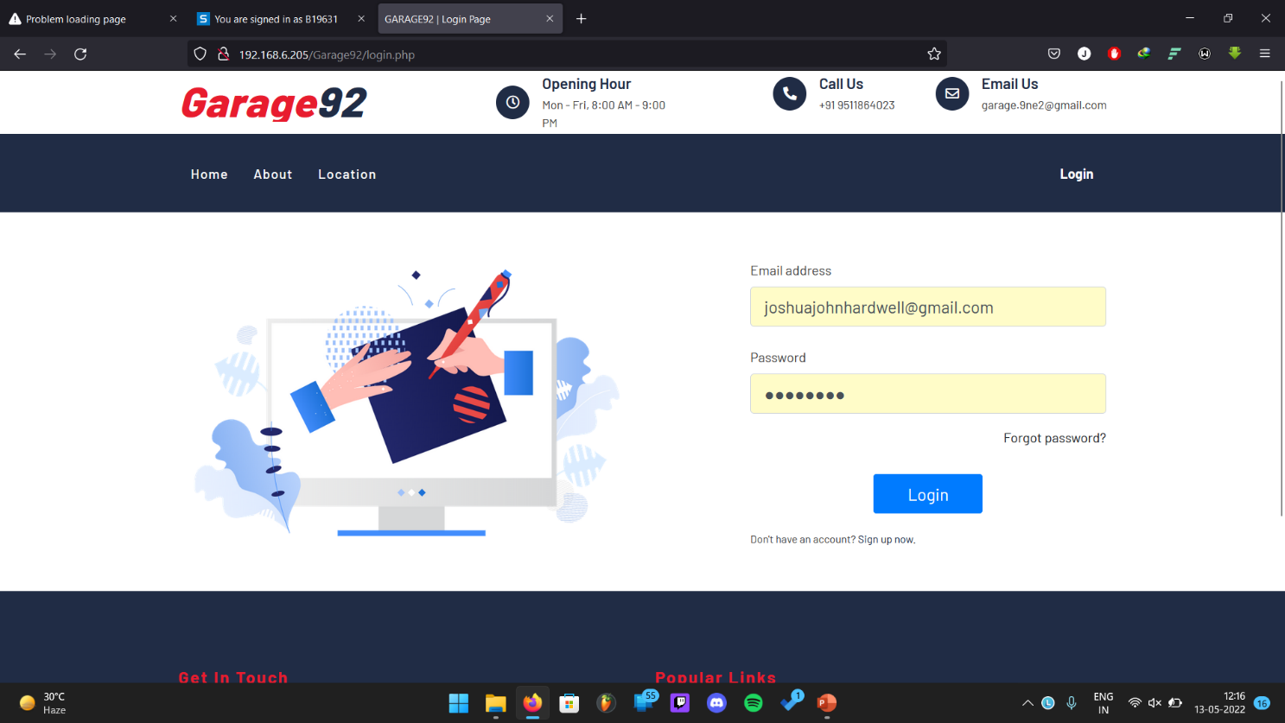

**Fig 18: User Page**

**7.1.3 Change password**

User Can change the password.

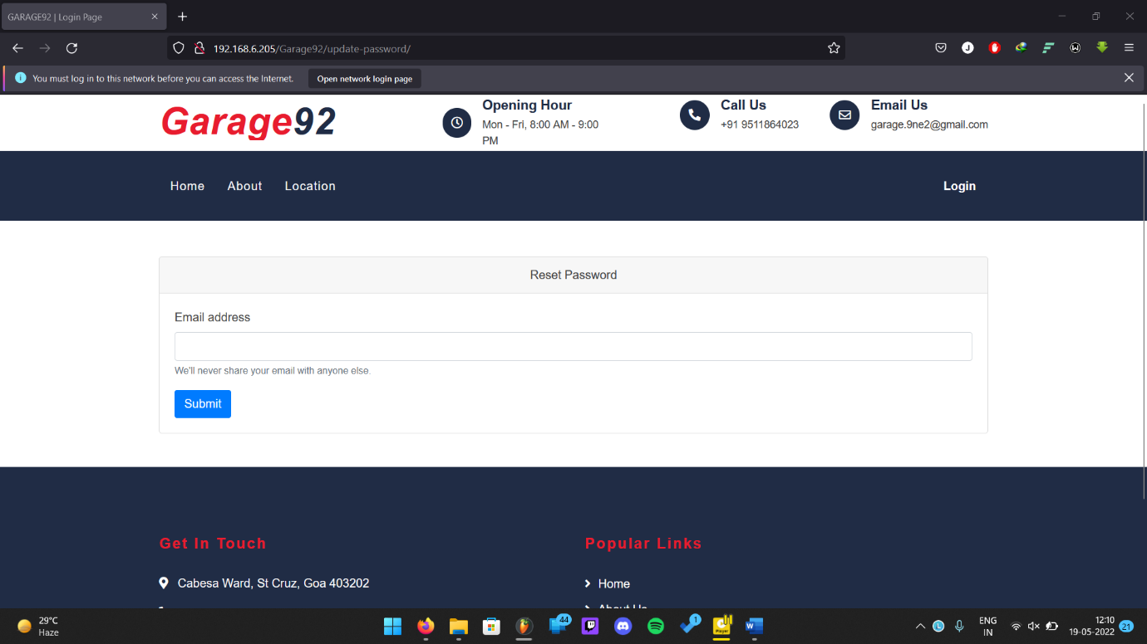

**Fig 19: Change password**

**7.1.4 Home Page**

User Home page will open after log-in

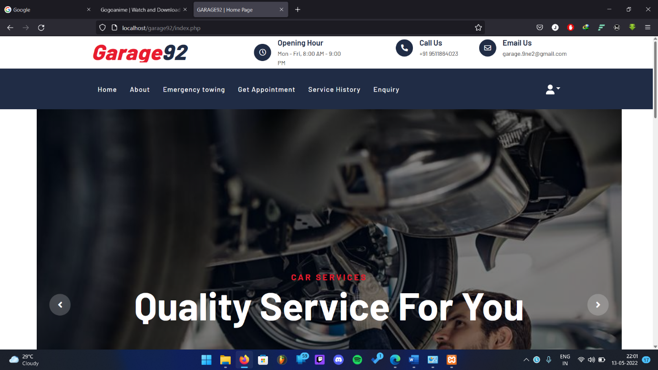

**Fig 20: Home Page**

**7.1.5 About us**

Will display about the information about the garage 92

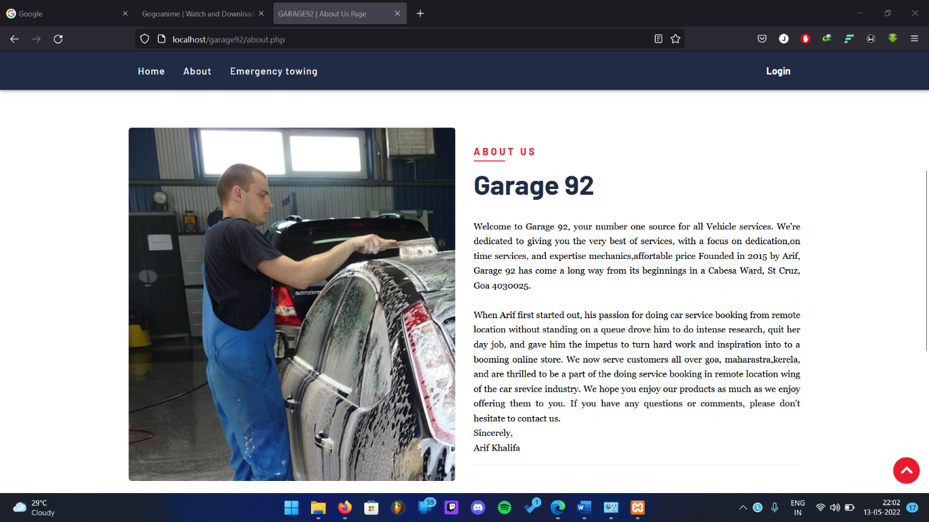

**Fig 21: About us**

**7.1.6 Contact ID and footer**

Display’s contact information and page link

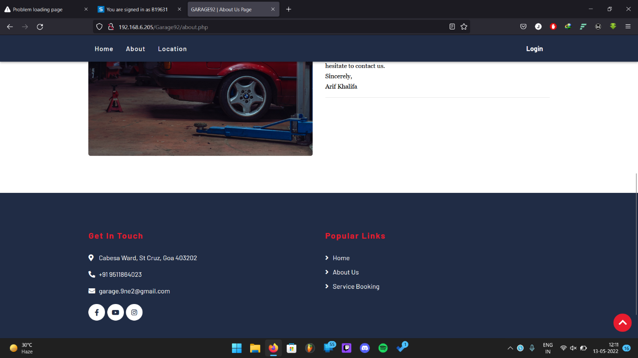

**Fig 22: Contact ID and footer**

**7.1.7 Location**

It will show the location of the garage

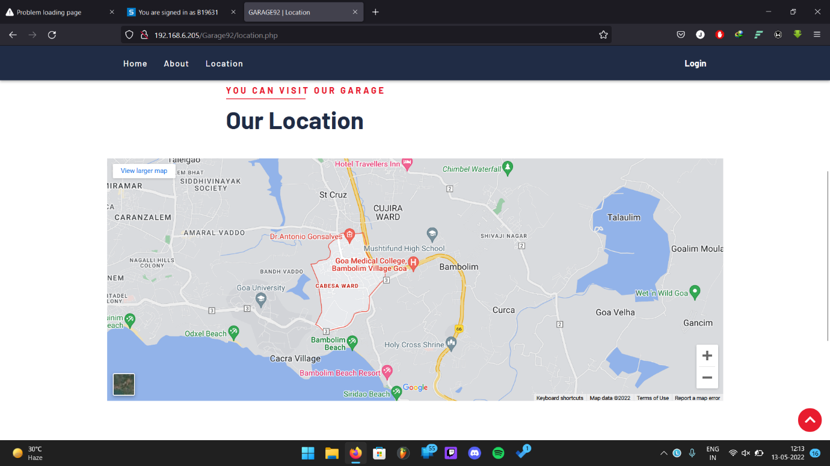

**Fig 23: Location**

**7.1.8 Booking page**

Displays booking page to the user after clicking get appointment.

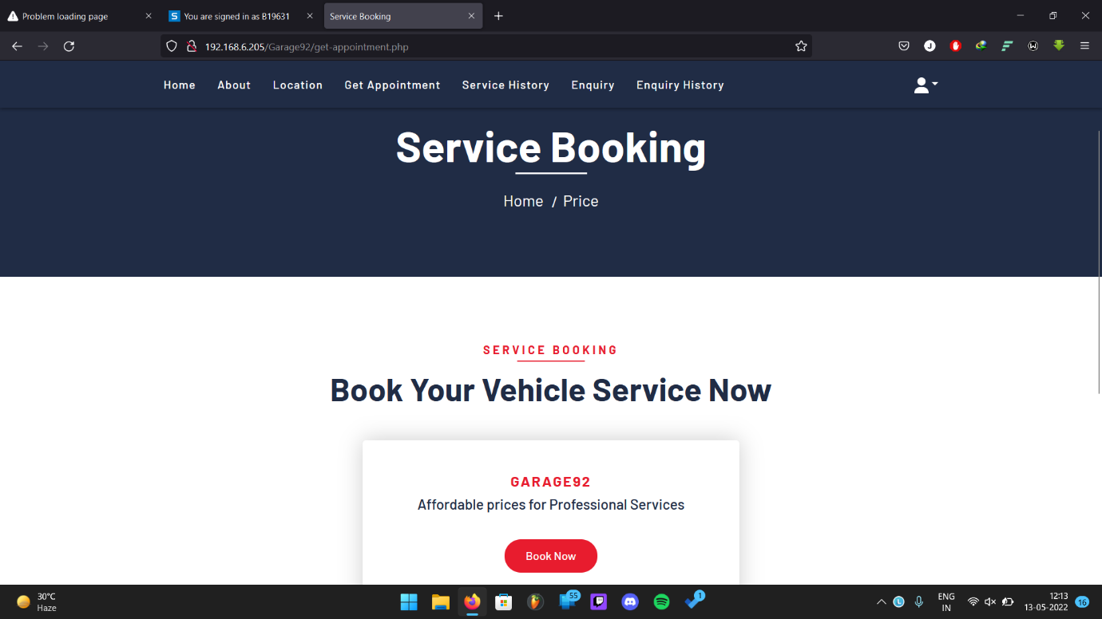

**Fig 24: Booking page**

**7.1.9 Booking Form**

Once the book button is clicked the service form will be displayed.

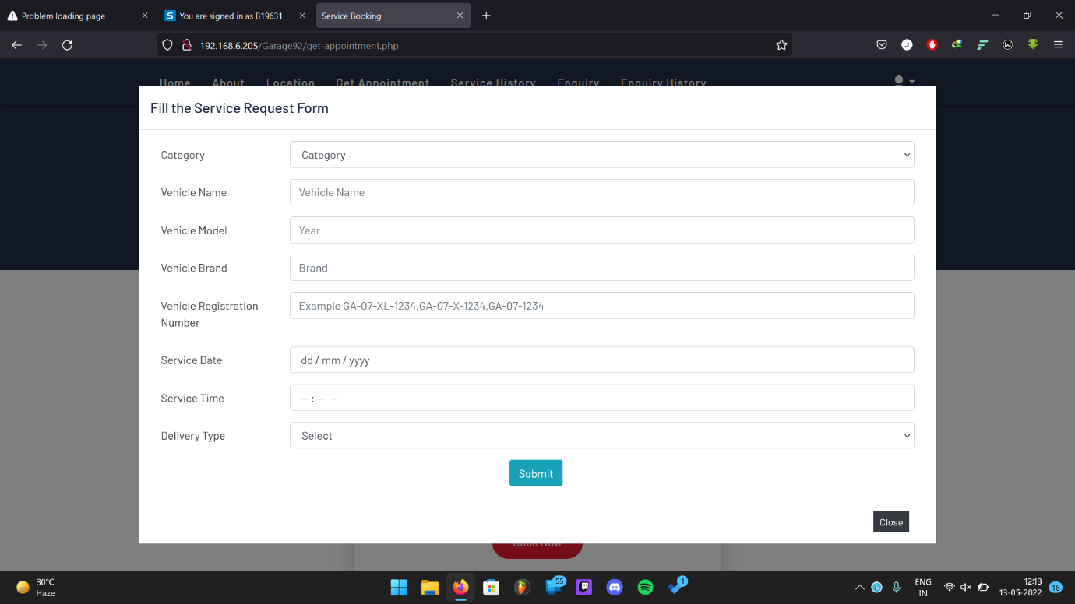

**Fig 25: Booking Form**

**7.1.10 Service History**

Check the service history know if the service is accepted or rejected

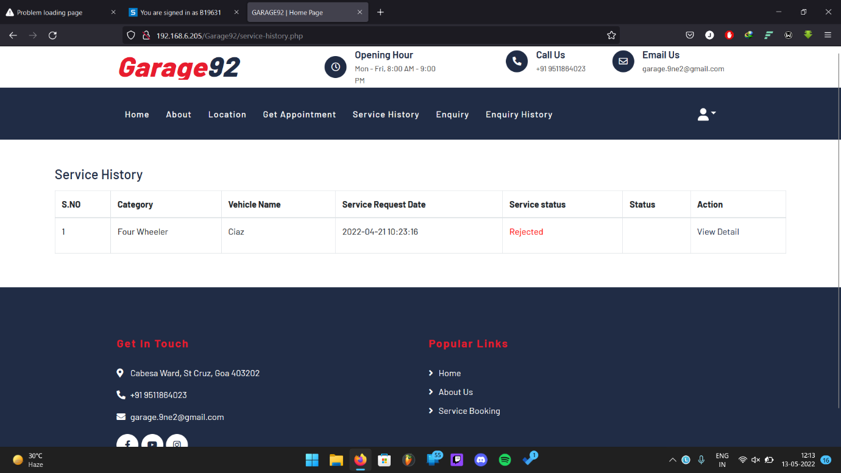

**Fig 26: Service History**

**7.1.11 Enquiry page**

Here the user Can enquire about the services and more

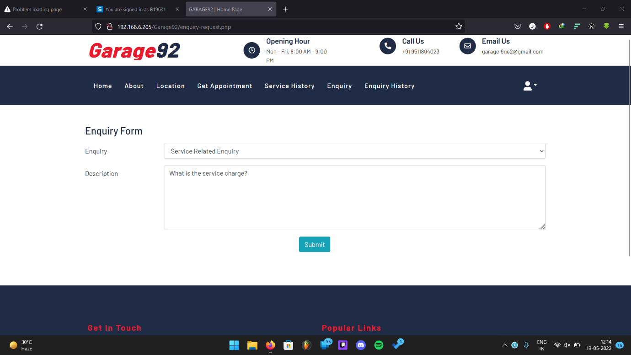

**Fig 27: Enquiry page**

**7.1.12 Enquiry History**

Here to check if the admin has replied to the enquiry that user has send.

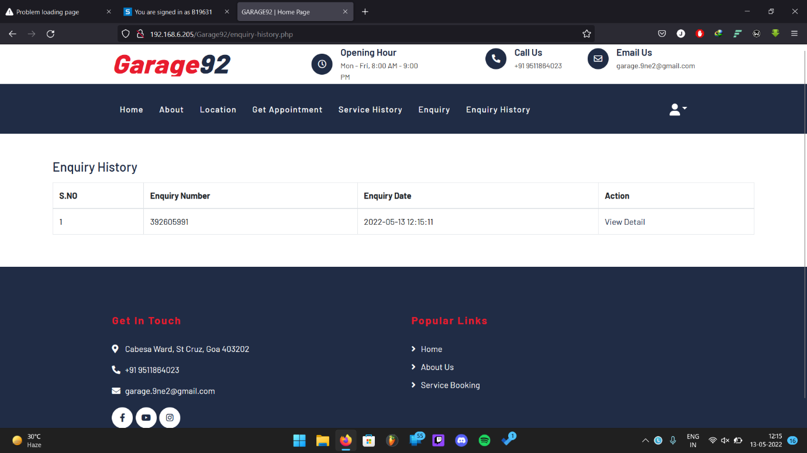

**Fig 28: Enquiry History**

**7.1.13 My Profile**

You can see your profile and also update the details.

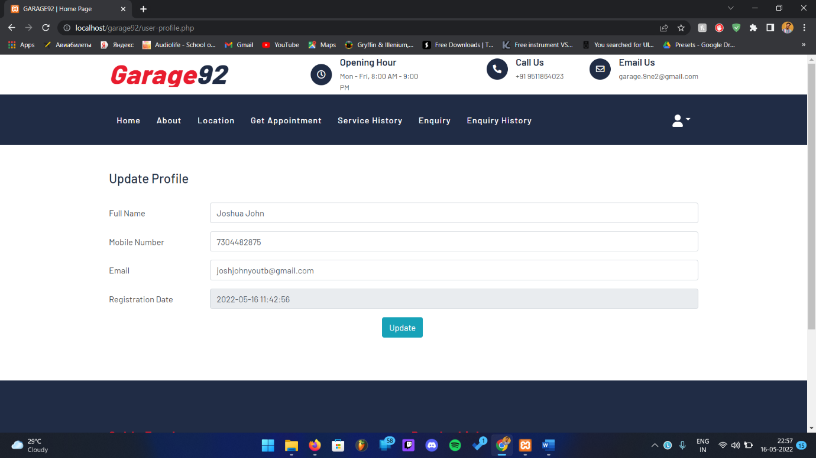

**Fig 29: My Profile**

**7.2 Admin**

**7.2.1 Admin log-in**

Admin can log-in to access his dashboard.

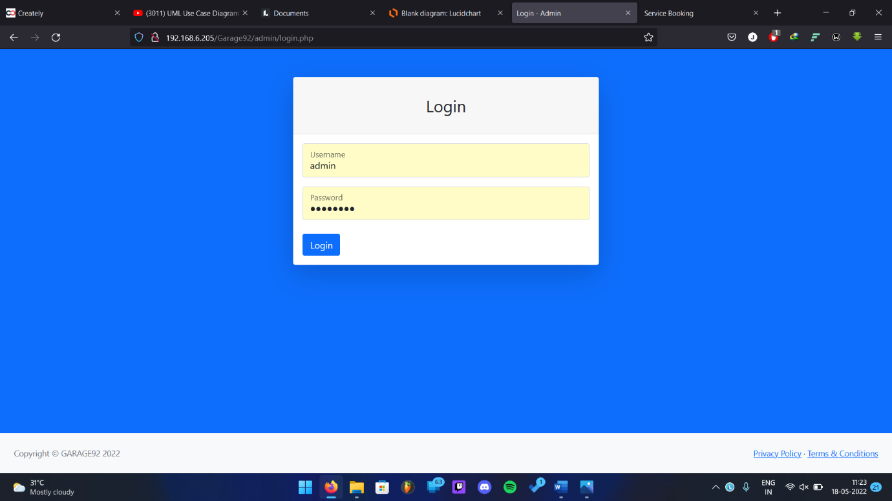

**Fig 30: Admin log-in**

**7.2.2 Change Password**

Admin can change is password here.

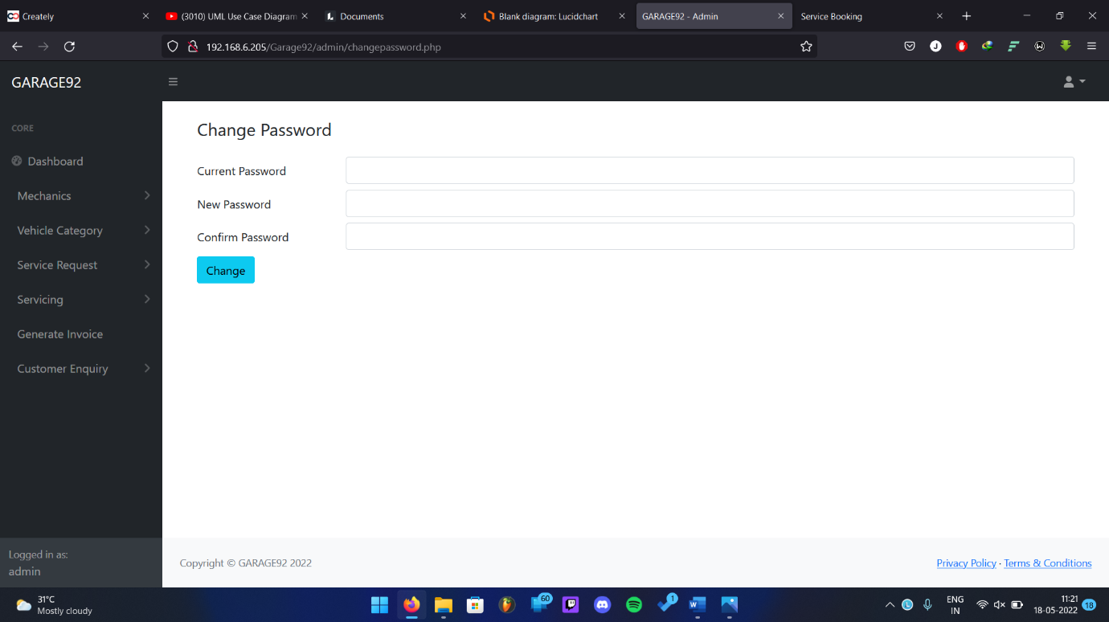

**Fig 31: Change Password**

**7.2.3 Admin Dashboard**

Admin will get to know how many service and total mechanics and other information here.

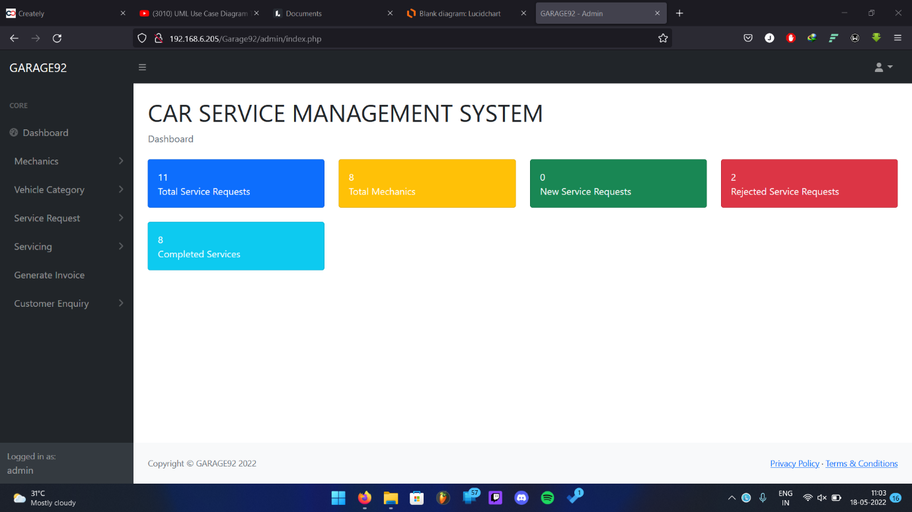

**Fig 32: Admin Dashboard**

**7.2.4 Add Mechanics**

Admin can add new mechanics here.

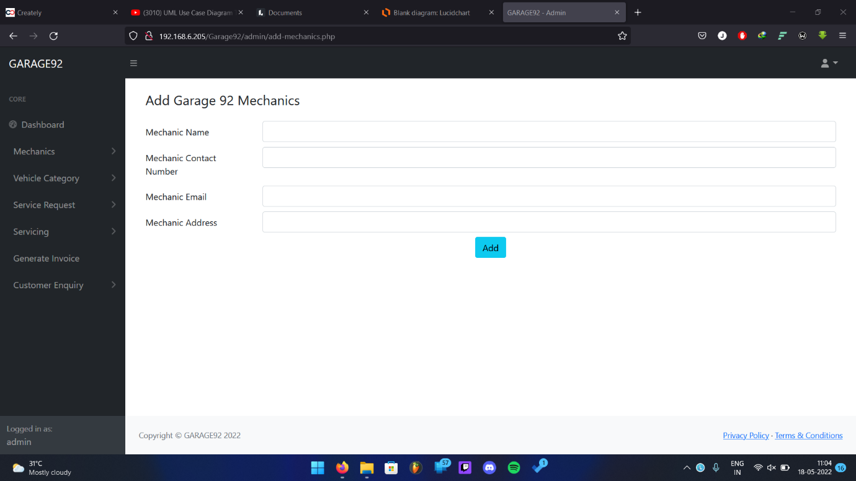

**Fig 33: Add Mechanics**

**7.2.5 Manage mechanics**

Admin can edit or delete mechanics information.

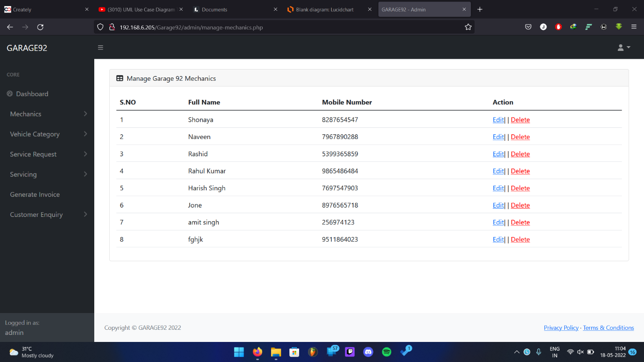

**Fig 34: Manage mechanics**

**7.2.6 Add Vehicle category**

Admin can add new vehicle category

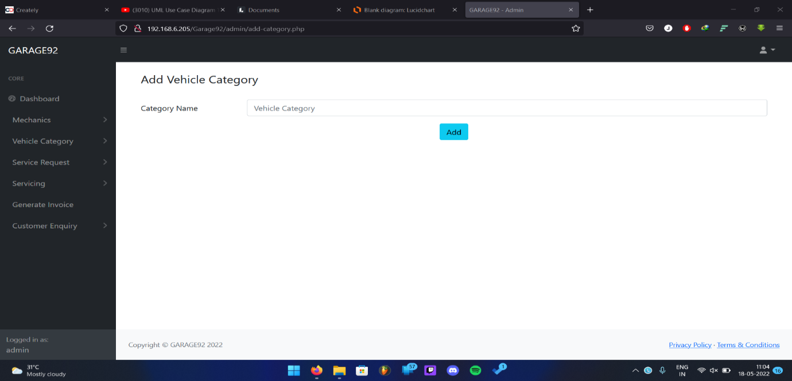

**Fig 35: Manage mechanics**

**7.2.7 Manage category**

Admin can add edit or delete vehicle information.

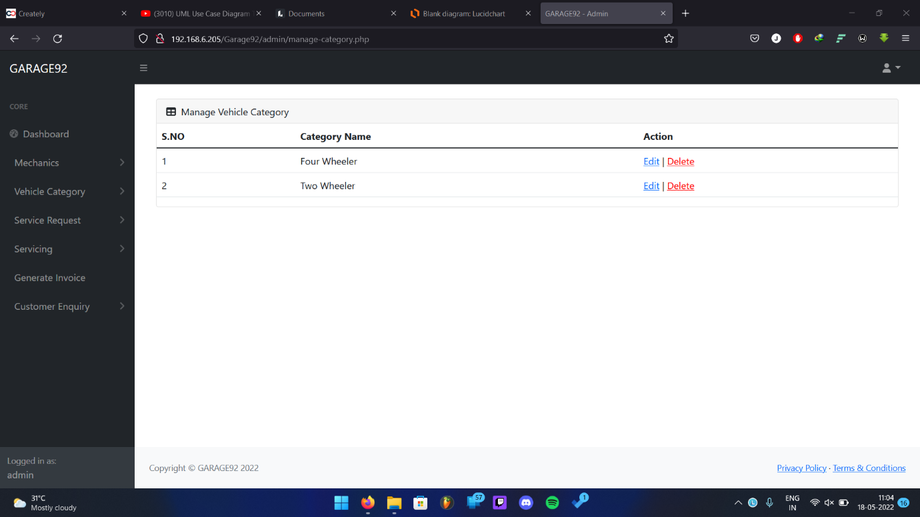

**Fig 36: Manage category**

**7.2.8 Service request new**

Admin can see the new service request

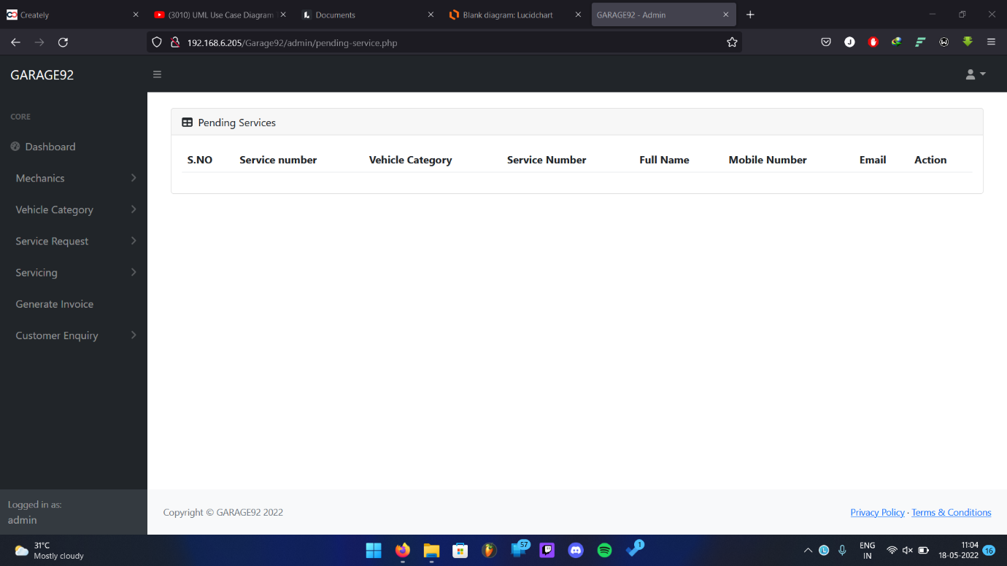

**Fig 37: Service request new**

**7.2.9 Service Rejected**

Admin can see which service has been rejected.

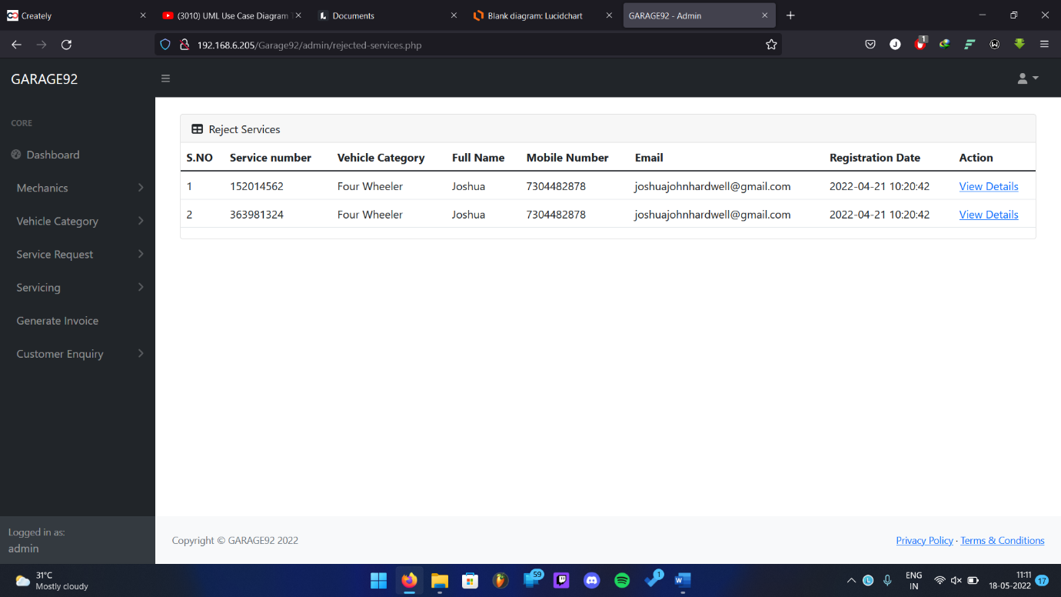

**Fig 38: Service Rejected**

**7.2.10 Service Pending**

Service that is being rejected by admin will be displayed.

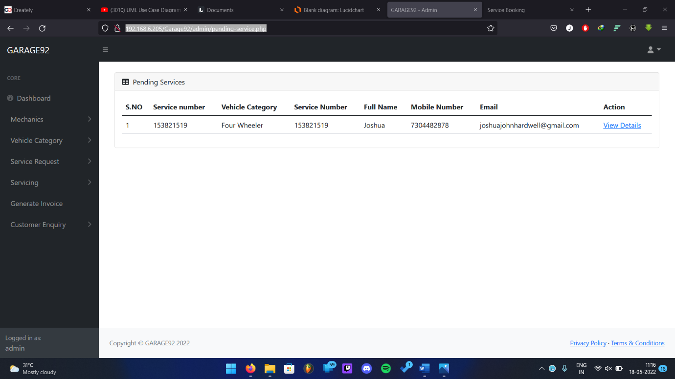

**Fig 39: Service Pending**

**7.2.11 Service Completed**

Service that is completed will show below.

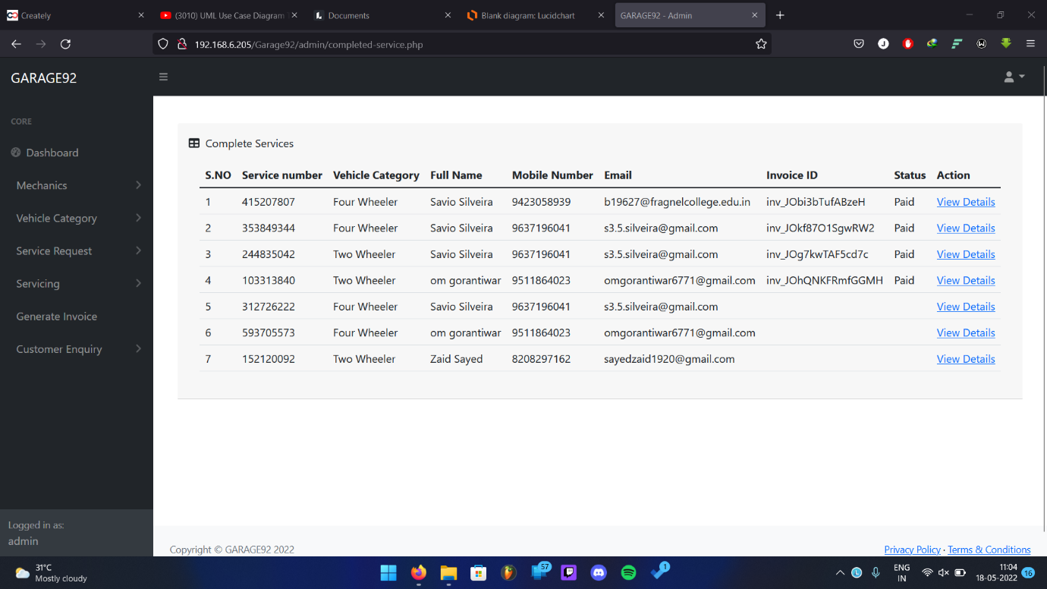

**Fig 40: Service Completed**

**7.2.12 Generating invoice**

Admin can create invoice to the user here.

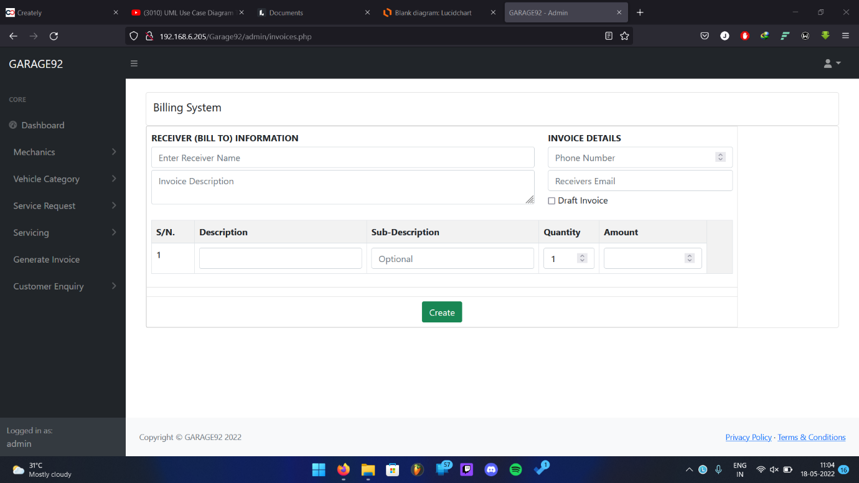

**Fig 41: Generating invoice**

**7.2.13 Customer Enquiry**

In this page it displays the enquiry asked by the user.

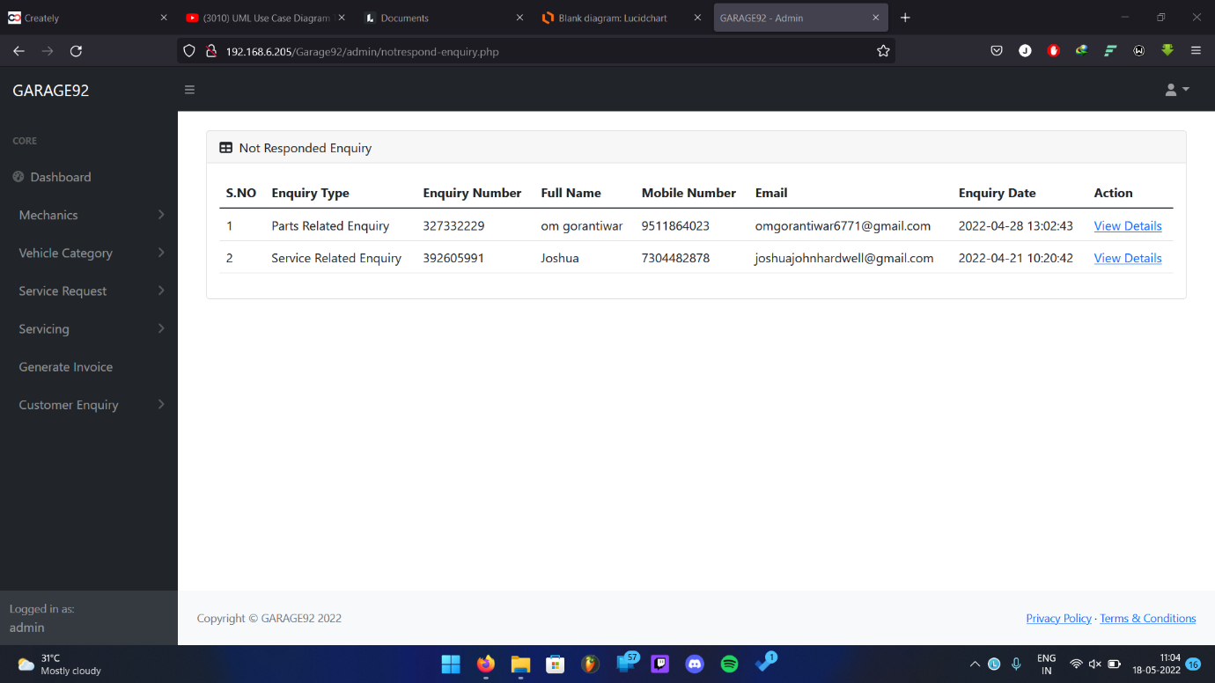

**Fig 42: Customer Enquiry**

**7.2.14 Responded Enquiry**

Here the admin can see which enquiry he has responded.

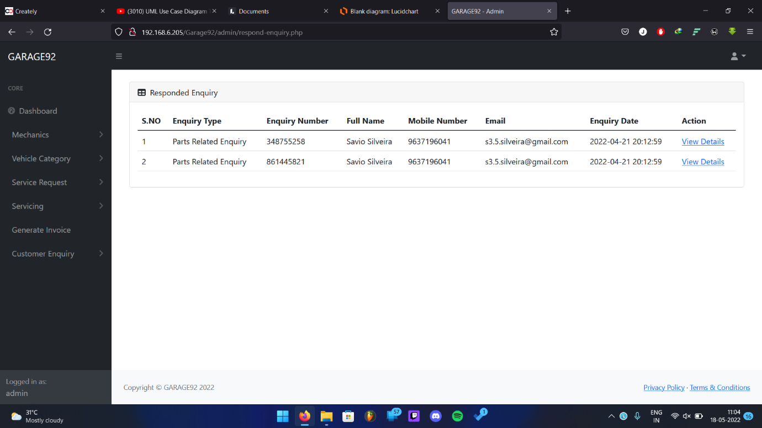

**Fig 43: Responded Enquiry**

**CHAPTER 8**

**CONCLUSION**

**AND**

**FUTURE ENHANCEMENT**

**8.1 Conclusion**

* The package was designed in such a way that future modifications can be done easily. The following conclusions can be deduced from the development of the project.
  + Automation of the entire system improves the efficiency
  + It provides a friendly graphical user interface which proves to be better when compared to the existing system.
  + It gives appropriate access to the authorized users depending on their permissions.
  + It effectively overcomes the delay in communications.
  + Updating information becomes so easy.
  + System security, data security and reliability are the striking features.
  + The System has adequate scope for modification in future if it is necessary.

**8.2 Future enhancement**

Future enhancements that can be made possible are

* Monthly Service reminder for user
* Vehicle Modification request form
* Notifying the new service request for admin

**8.3 References**

**Php**

[https://www.w3schools.com/php](https://www.w3schools.com/php/php_functions.asp)

<https://github.com/PHPMailer/PHPMailer>

**Razorpay**

<https://razorpay.com/docs/payments/server-integration/php/payment-gateway>

**Html**

<https://www.w3schools.com/html>

<https://developer.mozilla.org/en-US/docs/Web/HTML>

**CSS**

[https://www.w3schools.com/css/](https://www.w3schools.com/css/css_selectors.asp)

<https://developer.mozilla.org/en-US/docs/Web/CSS>

**JavaScript**

<https://developer.mozilla.org/en-US/docs/Web/JavaScript>

**8.4 Bibliography**

* Learning PHP MySQL and JavaScript by Robin Nixon 4th edition
* Html 5 and CSS by code academy (2022)
* JavaScript and jQuery by Jon Duckett 1st edition

Annexure III

**Name of college:** Fr. Agnel College of Arts and Commerce, Pilar-Goa

**Course:** Bachelors of computer application

**Year:** 2021-2022

**Title of the Project:** Garage92 “Web-based application for Vehicle Service Management System”

|  |  |  |  |  |  |
| --- | --- | --- | --- | --- | --- |
| **Library / Laboratory**  **Fieldwork** | **Description of work** | **Date** | **Time Spent** | **Signature of Authority** | **Counter Signature of Guide & Date** |
| **Project Research** | Identifying a Project | 1-10-2021 to  19-10-2021 | 1 hour per day |  |  |
| **Requirement & Analysis** | Requirement Gathering and defining of scope & feasibility Study | 20-10-2021  To  10-12-2021 | 1 hour per day |  |  |
| **Design** | Designing Use case & ER Diagram, class diagram, activity diagram, use case diagram for garage 92 Website | 13-12-2022  To  10-01-2022 | 1 hour per day |  |  |
| **Implementation**  **Module 1** | Developing & testing Login & Logout page for user and admin | 12-01-2022  To  25-02-2022 | 1 hour per day |  |  |
| **Implementation**  **Module 2** | Developing and testing registration page for user | 17-01-2022  To  25-02-2022 | 1 hour per day |  |  |
| **Implementation**  **Module 3** | Developing and testing Homepage & location and about page for user | 01-03-2022  To  28-03-2022 | 1 hour per day |  |  |
| **Implementation**  **Module 4** | Developing and testing appointment page for user | 21-02-2022  To  28-03-2022 | 1 hour per day |  |  |
| **Implementation**  **Module 5** | Developing and testing Update Profile page for user | 25-03-2022  To  21-04-2022 | 1 hour per day |  |  |
| **Implementation**  **Module 6** | Developing and testing enquiry request page for user | 02-03-2022  To  04-04-2022 | 1 hour per day |  |  |
| **Implementation**  **Module 7** | Developing and testing service history page for user | 04-04-2022  To  20-04-2022 | 2 hours per day |  |  |
| **Implementation**  **Module 8** | Developing and testing enquiry history page for user | 11-04-2022  To  21-04-2022 | 3 hours per day |  |  |
| **Implementation**  **Module 9** | Developing and forgot and change page for user | 08-04-2022  To  21-04-2022 | 2 hours per day |  |  |
|  |  |  |  |  |  |
| **Implementation**  **Module 10** | Developing and testing Payment module for admin | 25-04-2022  To  04-05-2022 | 2 hours per day |  |  |
| **Implementation**  **Module 11** | Developing and testing Bill page for user | 20-04-2022  To  28-04-2022 | 3 hours per day |  |  |
| **Implementation**  **Module 12** | Developing and testing Admin Dashboard module for admin | 04-04-2022  To  13-04-2022 | 3 hours per day |  |  |
| **Implementation**  **Module 13** | Developing and testing Admin vehicle category module for admin | 21-03-2022  To  14-04-2022 | 2 hours per day |  |  |
| **Implementation**  **Module 14** | Developing and testing mechanics module for admin | 05-04-2022  To  15-04-2022 | 1 hours per day |  |  |
| **Implementation**  **Module 15** | Developing and testing Admin Profile Update module for admin | 25-03-2022  To  18-04-2022 | 2 hours per day |  |  |
| **Implementation**  **Module 16** | Developing and testing service request module for admin | 11-04-2022  To  17-04-2022 | 2 hours per day |  |  |
| **Implementation**  **Module 17** | Developing and testing enquiry request module for admin | 16-03-2022  To  16-04-2022 | 2 hours per day |  |  |
| **Implementation**  **Module 18** | Developing and testing servicing module for admin | 11-04-2022  To  20-04-2022 | 2 hours per day |  |  |
| **Integration testing** | Testing the functionality of the web application as a whole. | 22-04-2022 to  04-05-2022 | 2 hours per day |  |  |

|  |  |  |
| --- | --- | --- |
| **Roll No** | **Name** | **Signature** |
| B19601 | Mr Murtaza Azizi |  |
| B19622 | Mr. Zaid Sayed |  |
| B19627 | Mr. Savio Silveira |  |
| B19630 | Mr. Om Gorantiwar |  |
| B19631 | Mr. Joshua John |  |

___________ __________________

Ms. Arti Naik Ms. Nitisha Govekar

(Internal Guide) (Project Co-ordinator)

Annexure VII

|  |  |
| --- | --- |
| **Task** | **Duration** |
| Requirement & Analysis | 15-10-2021 to 10-12-2021 |
| Design | 13-12-2021 to 10-01-2022 |
| Implementation | 12-01-2022 to 20-04-2022 |
| Testing | 22-04-2022 to 04-05-2022 |

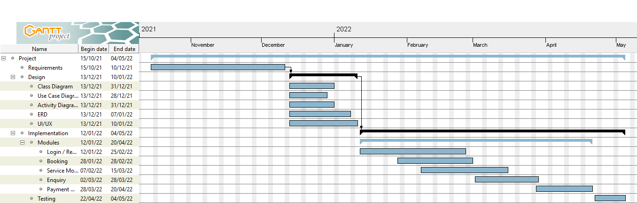

Annexure V

Fr. Agnel College of Arts and Commerce, Pilar-Goa

**Pilar-Goa**

**2021-2022**

**Declaration by candidates**

We declare that the project report has been prepared by us and to the best our knowledge, it has not previously formed the basis for the award of any diploma or degree by this or any other University.

|  |  |  |
| --- | --- | --- |
| **Roll No** | **Name** | **Signature** |
| B19601 | Mr Murtaza Azizi |  |
| B19622 | Mr. Zaid Sayed |  |
| B19627 | Mr. Savio Silveira |  |
| B19630 | Mr. Om Gorantiwar |  |
| B19631 | Mr. Joshua John |  |